**Phyton Zero to Mastery**

**Section 1: Intorduction**

1. Course Outline
2. Join online classroom
3. Meet your classmates and instructor
4. ZTM Resources
   1. <https://zerotomastery.io/>
   2. <https://www.youtube.com/@ZeroToMastery>
   3. <https://www.linkedin.com/groups/12121940/>

**Section 2: Phyton Introduction**

1. What is a programming language
2. Phyton Interpreter
   1. <https://www.python.org/>
3. How to run Phyton Code
   1. Basic computer setup requires
      1. Terminal
      2. Code editors (sublime or Visual Studio Code)
      3. IDEs (Spyder, Pycharm)
      4. Notebook (Jupiter)
   2. <https://replit.com/> - with pay
      1. Create an account
      2. Press Create App, Choose a template (phyton) and name the app, press create app
   3. <https://glot.io/> - free
4. Latest Version of Phyton (3)
5. Jumping to developer environment
6. 10. First Phyton Program
   1. 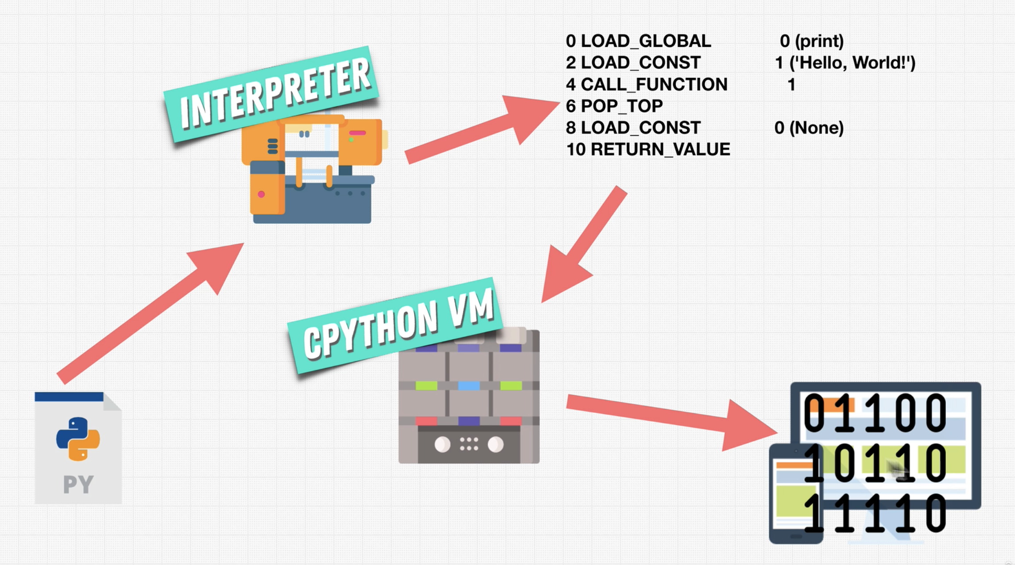
   2. First sample code
      1. 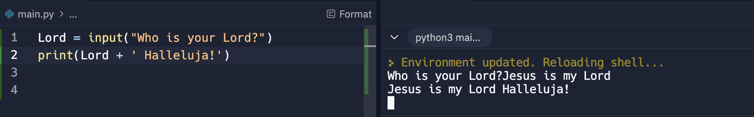
      2. Input is a function that accepts entry and was stored to the memory. Then the variable was printed
7. Monthly coding challenge
8. Phyton 2 vs Phyton 3
   1. The sotyr of Phyton - <https://www.youtube.com/watch?v=J0Aq44Pze-w>
   2. Phyton 2 vs Phyton 3 - <https://sebastianraschka.com/Articles/2014_python_2_3_key_diff.html>
   3. Phyton 2 vs Phyton 3 - <https://www.geeksforgeeks.org/important-differences-between-python-2-x-and-python-3-x-with-examples/>
9. Why so many languages
   1. List of languages - <https://en.wikipedia.org/wiki/List_of_programming_languages>
10. How Phyton works – Phyton is a high level programming language that boast for its ease of learning, a great tool for machine learning, data analyzation, web development etc. It starts with a .py file or the main.py as a source code, and when it runs, the code is pass to an interpreter (like replit.org). The interpreter converts the code to binary and process by the C Phyton Vm and splits the output to machine
11. Phyton cheat sheet –
    1. /Users/sherwinnofuente/Desktop/Python_Cheatsheet_Zero_To_Mastery_V105.pdf
    2. Finally, a fellow student has made this for all code used in this course! This way you can always check your code against it if you are getting any errors as you go through the course: <https://github.com/aneagoie/All-Python-codes-of-ZTM-course-by-Andrei-Neagoie>
12. Phyton Developer Monthly
    1. Every month, I accumulate all of the best resources and articles, as well as free resources around the web for Python Developers. If you want to stay up to date with the industry and make sure you don't miss any important news, you can check out the monthly newsletter here. [**It's completely free every month**](https://zerotomastery.io/newsletters/python-monthly/)!
    2. Don't worry if the topics in the newsletter are still difficult. By the end of this course, you will have all the skills necessary to read everything and understand them :)
    3. **AI & Machine Learning Monthly / Web Developer Monthly:** There is also a Machine Learning Monthly (written by Daniel) and Web Developer Monthly newsletter if you are interested. You can read past issues [**here**](https://zerotomastery.io/newsletters/)**.**
13. Endorsement on LinkedIn
    1. If you are looking to improve your LinkedIn profile and have others endorse your skills, we have a private ZTM[LinkedIn group here](https://www.linkedin.com/groups/12121940/). LinkedIn allows you to have recruiters message you with lots of job opportunities. You can join the group by clicking on "LinkedIn Group" and then go ahead and endorse some of the member's skills (other people will do the same for you as they join).  
         
       If you have any questions, reach out in our private Discord chat community in the #job-hunting channel!  
         
       UPDATE!!! Zero to Mastery is officially a recognized school! What does this mean for you? It means that you can add it as an educational institution on LinkedIn as part of your profile to wow those employers (as your education history). [Check it out here](https://www.linkedin.com/school/64685953/). To add it to your profile:
    2. Step 1: Go to personal LinkedIn profile
    3. Step 2: Scroll down to the Education section
    4. Step 3: Click the +
    5. Step 4: Type in Zero To Mastery Academy
    6. Course content
    7. AI Assistant

**Section 3: Phyton Basics**

1. Learning Phyton
   1. 4 key things to master
      1. Terms – definitions
      2. Data Types – what sort of data a language can hold
      3. Actions –
      4. Best Practices
2. Phyton Data Types - values in Phyton
   1. Fundamental Data Types
      1. Int – numbers
      2. Float
      3. Bool – Boolean
      4. Str – string
      5. Tuple
      6. Set
      7. Dict
   2. Classes – custom types
   3. Specialized data types – not built in to Phytons. Normally libraries or extensions
   4. None – simply nothing
3. How to succeed
   1. In order to get the most out of the course, I encourage you to code along with me throughout the next sections. Watching videos may help, but nothing beats hands on practice and actually coding to develop your skills and make you comfortable with Python. Let's get started!
4. Numbers
   1. Int – whole number
   2. Float – number with decimal point; <https://www.youtube.com/watch?v=PZRI1IfStY0>
   3. Double multiply ( \*\* ) - power. Example 2 \*\* 2 = 4; 2^2=4
   4. Double divide ( // ); round down; 2 // 4 = 0.
   5. Modulo ( % ); the remainder; 5 % 4 = 1
5. Math functions - <https://www.programiz.com/python-programming/modules/math>
   1. Round(number, ndigits)
   2. Abs – absolute; no negative
6. Developer Fundamentals I
   1. How to avoid mistakes
   2. Key things to make efficient in learning and becoming a good programmer
   3. Do not read the dictionary – learn only what is needed; little by little
   4. Be good in googling
   5. Understand what exist and how to use
7. Operator Precedence
   1. () – bracket first
   2. \*\* - power
   3. Multiply or divide
   4. Addition or subtraction
8. Repit code –
   1. In the next lesson you will start seeing links to my Replit profile which will have code from the videos you will watch throughout the course. Sometimes, Replit servers can have issues/or be down, so please take note of 2 important things you can do to make sure you can follow the course without interruptions:  
        
      1. You can always find the Replit code on [my github repo specific to this course right here](https://github.com/aneagoie/ztm-python-course-exercises) so you have it in one place throughout the course.  
        
      2. When you click on the link of a Replit project (like in the next lecture), you will see something similar to below. Make sure you CLICK ON THE "SHOW CODE" icon so you can see my code:
      1. 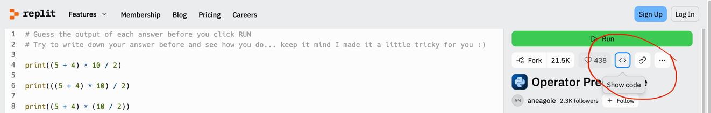
9. Exercise: Operator Precedence
10. Optional: bin() and complex - <https://www.geeksforgeeks.org/python-int-function/>
11. Variables - <https://www.w3schools.com/python/python_ref_keywords.asp>
    1. Stores information
    2. Snake\_case – space is underscore or private variable
    3. Start with lower case or underscore
    4. Letters, numbers, underscore
    5. Case sensitive
    6. Don’t overwrite words
    7. Do not create variable with \_\_
12. Expression vs Statements
    1. Example: user\_age = 2 /4
    2. Expression – 2 / 4
    3. Statement – user\_age = 2 / 4
13. Augmented Assignment Operator
    1. 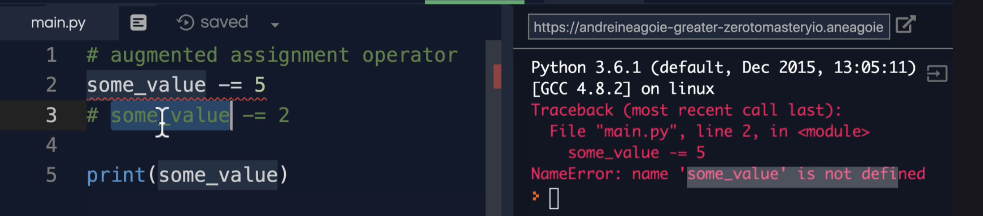
14. Strings – text. Expressed by double or single quotes
15. String Concatenation – joining text
16. Type conversion – print(type(str(100))) – will result to 100 as string and not int
17. Escape Sequences – this is to address the hyphen in strings
18. Formatted Strings
    1. 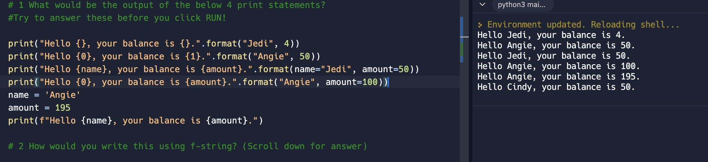
    2. .format is an old way of formatting strings.
    3. f at the beginning of the expression is the new way of formatting strings
19. String indexes – put each character in an array
    1. Sample is good\_boy = 1234567
    2. [start, stop, step over] – is string slicing
    3. [0] – 1
    4. [0:3] – 123;
    5. [1:] – up to the end; 234567
    6. [::2] – 1357; step over from the first character and jump or step over every two characters
    7. [-7] – 7; its like RIGHT in excel
    8. [::-1] -7654321; reverse the counting. Starts at the beginning, end at the end but the counting starts from the end to start
    9. 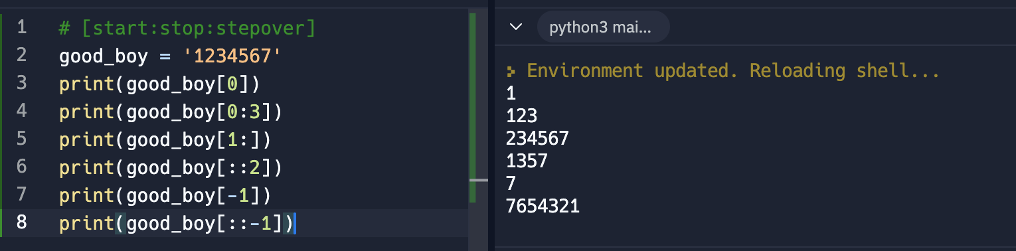
20. Immutability
    1. Strings are immutable or can’t just be changed. The variable needs to re-assign the value
    2. Changing the value of an existing variable from the memory. See the error below
    3. 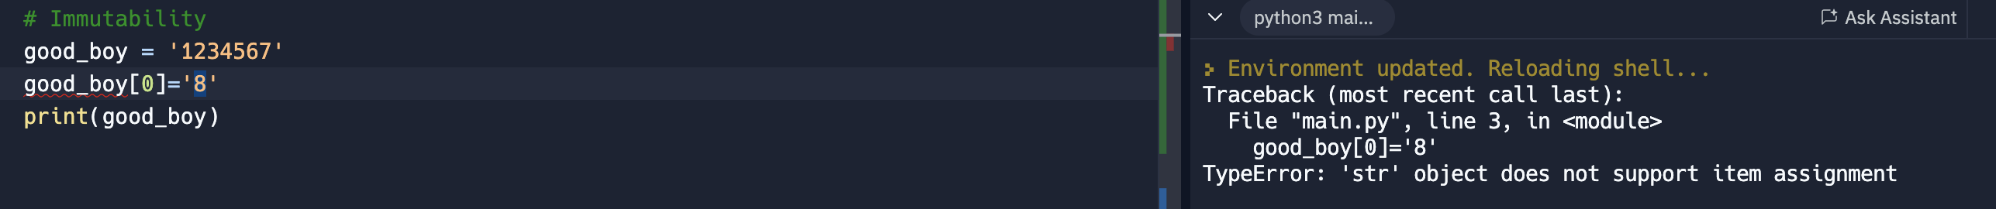
    4. 
    5. 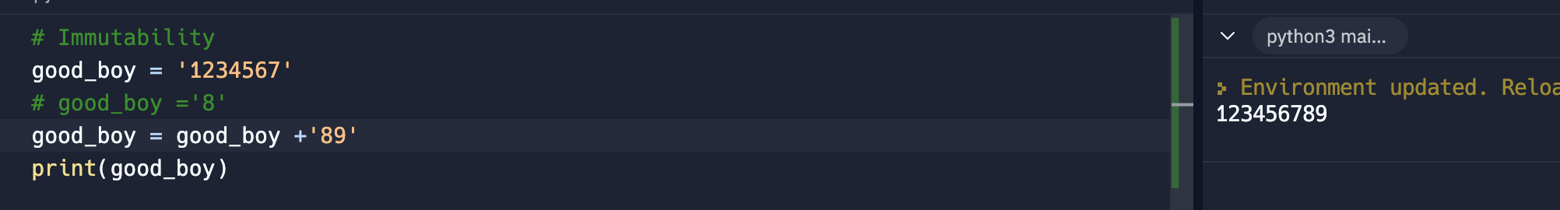
    6. Now the value of good\_boy = ‘8’ and the old goo\_boy = ‘1234567’ doesn’t exist anymore
21. Built in functions and + Methods
    1. Phyton Built in functions - <https://docs.python.org/3/library/functions.html>
    2. Phyton string methods - https://www.w3schools.com/python/python\_ref\_string.asp
    3. Len() – calculate the length of the string
    4. Methods are like functions but owned by something. Example, print() is a function, while count() is a method of that only strings can perform
       1. Function use parenthesis like print()
       2. Methods use . and parenthesis to initiate like .format()
    5. 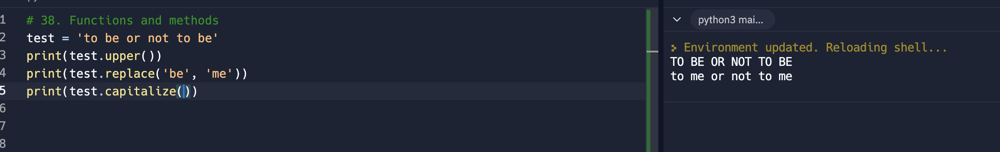
22. Booleans
    1. Booleans can only be true or false
    2. 1 – means True
    3. 0 – means False
    4. 
23. Exercise: Type conversion
    1. At this stage int, float, str and bool were discusses
    2. Below is an exercise to define the age after a question of what year you were born was asked
    3. 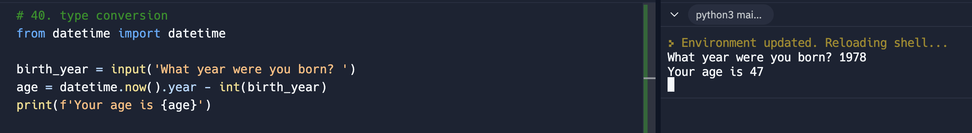
24. Developer Fundamentals II
    1. Commenting best practices - <https://realpython.com/python-comments-guide/>
    2. Be concise in making comments
25. Exercise: Password Checker
    1. 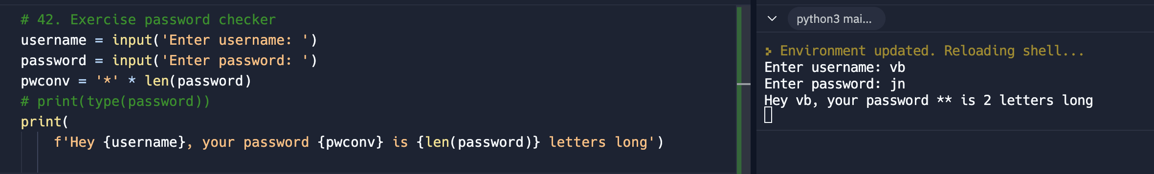

============================================= DATA STRUCTURES =======================================================

1. Lists
   1. A data structure
   2. Data are surrounded by [ ]
   3. Like array in JS
   4. A data structure
   5. Li = [1, ‘yes’. True, 2.5]
2. List slicing
   1. Same as string slicing
   2. List is mutable
   3. Mutable sample shows that the array object can be change directly without an error
   4. 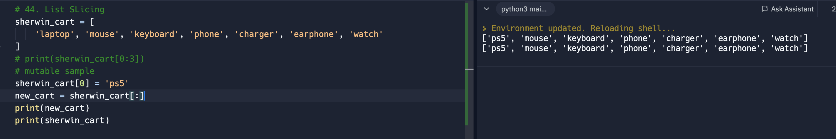
   5. new\_cart = sherwin\_cart, is a now a new copy of Sherwin\_cart resulting to different output
   6. 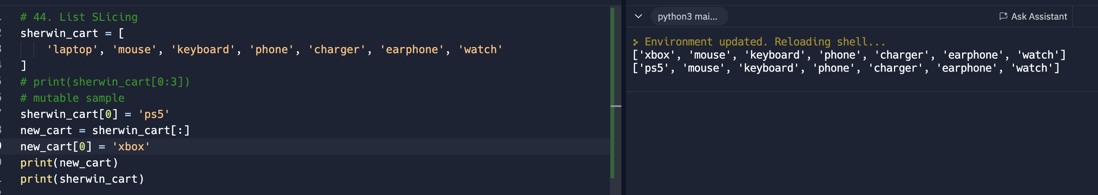
3. Matrix – is or are arrays inside an array use to display multi-dimensional list
   1. This is important for machine learning or image processing
   2. 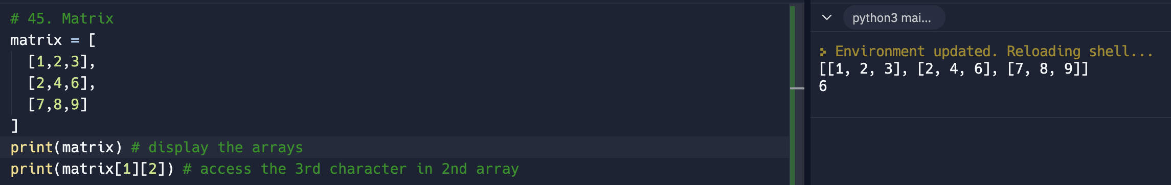
4. List Methods
   1. Adding
   2. 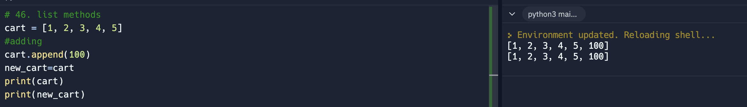
   3. Insert – insert anything inside a list. It modify the list in place and doesn’t create a new copy of the list
   4. 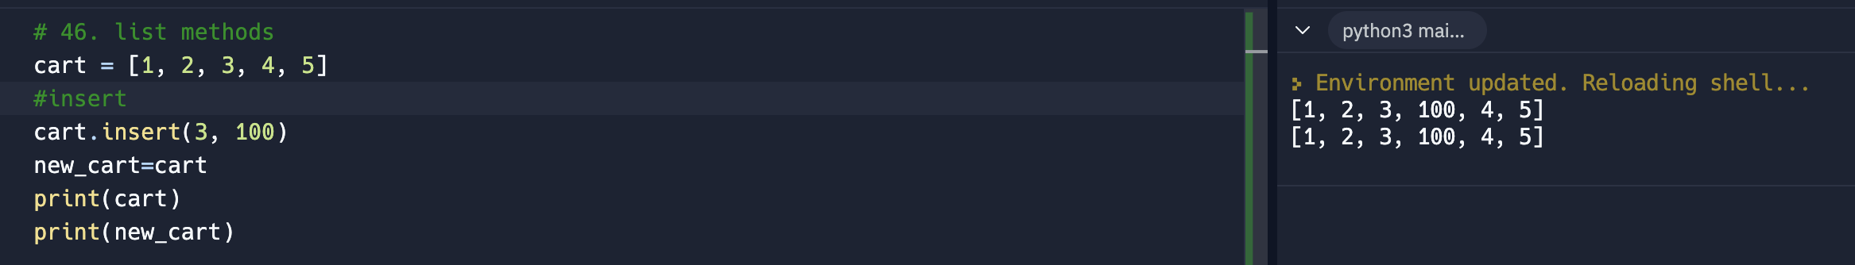
   5. Extend – can iterate or loop over each index of the list
      1. 1st print means that extend modify the list
      2. 2nd print means it doesn’t create a new list
   6. 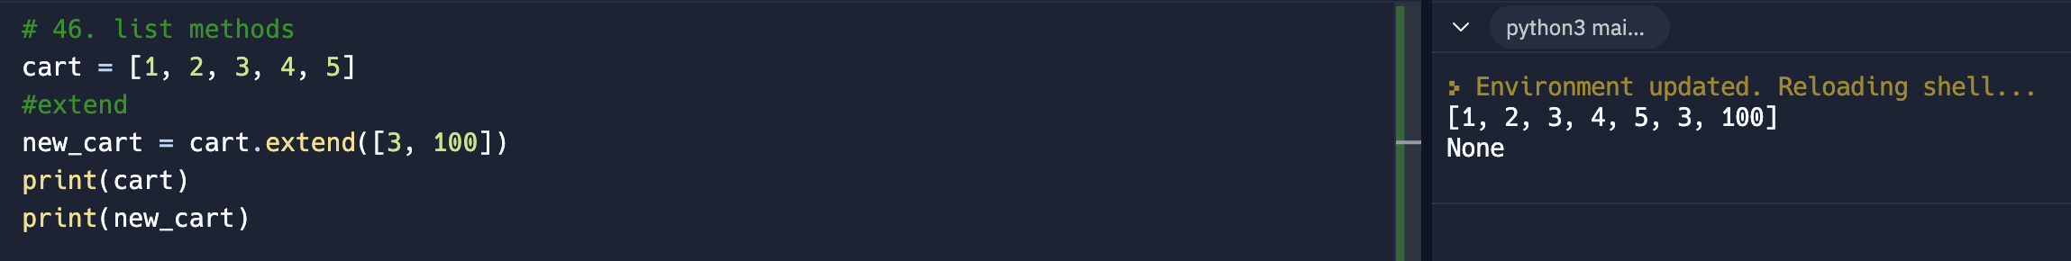
   7. Removing
      1. Pop – removes the index at the end of the list or the specified index. Can output the popped or removed item of the list
      2. Remove – remove the name of the element. Doesn’t output a new list
      3. If it displays None means a method that doesn’t return anything
      4. Clear – returns an empty list [ ]
      5. 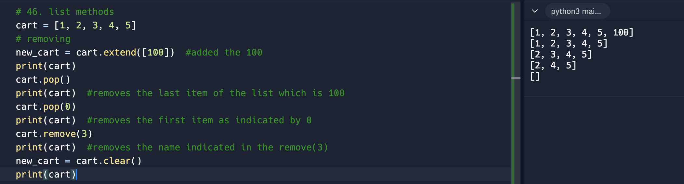
5. List Methods 2
   1. Shows the location of the item in the list. 0 and 5 in the sample is the range to look for the item
   2. In – is a keyword, use to check if the item to search is in the list
   3. Phyton keywords - https://www.w3schools.com/python/python\_ref\_keywords.asp
   4. Count – count the number of occurrence of an item in the list
   5. 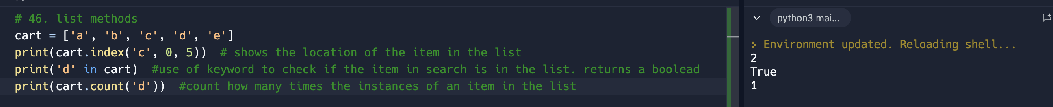
6. List Methods 3
   1. Sort – sorts the items in the list. It doesn’t produce an output
   2. 
   3. Sorted – is a function, sort also, but it returns a new output and doesn’t modify the list
   4. 
   5. Copy – just copy
   6. 
   7. Reverse – reverse the order of the items 
7. Common list patterns
   1. 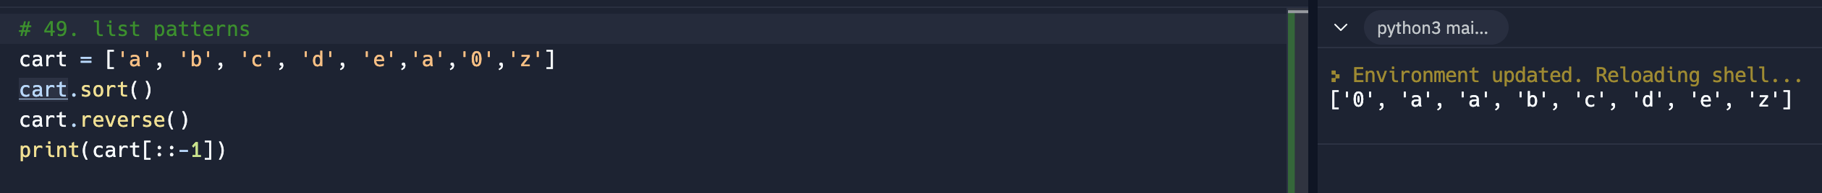
   2. 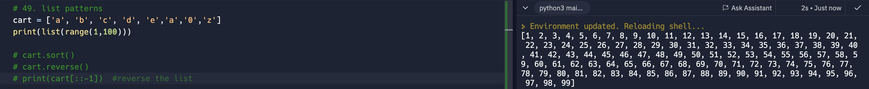
   3. 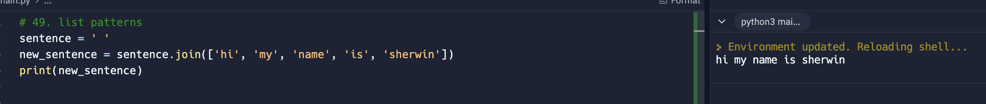
8. List Unpacking – similar to JS destructuring
   1. 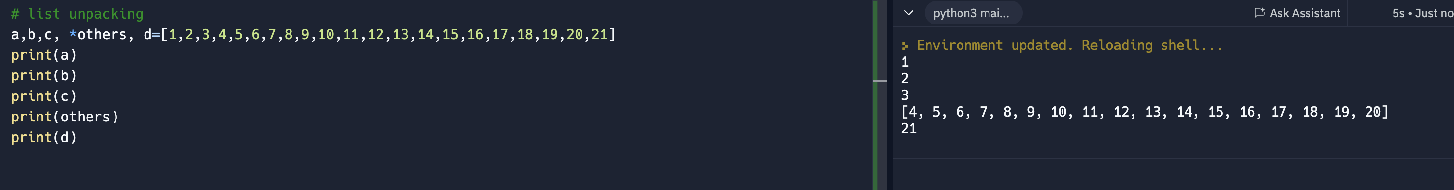
9. None – none
10. Dictionaries – like object in Javascript
    1. Another type of data structure
    2. Like list, dictionary is a container around data
    3. Data are surrounded by {}
    4. Unordered Key and value type of data structure; a key-value pair
    5. 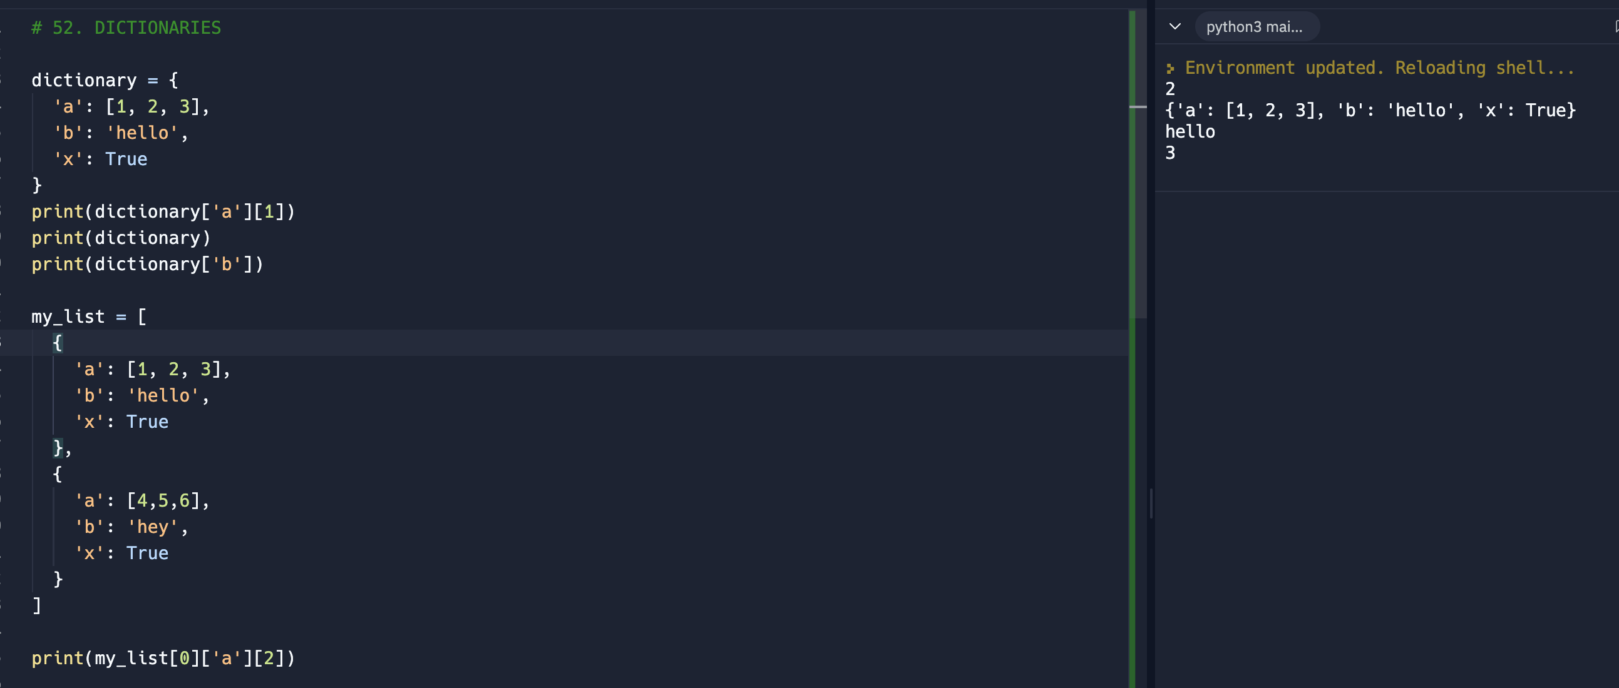
11. Phyton 3.7 Ordered Dict –
    1. Phyton 3.7 now has the capability to have the dictionary be orderly maintained
    2. <https://medium.com/junior-dev/python-dictionaries-are-ordered-now-but-how-and-why-5d5a40ee327f>
12. Developer Fundamentals III – when to use dict or list
    1. Use list when
       1. List are ordered
       2. Indexed and values
    2. Use dict when
       1. Dict are unordered
       2. Key-value pair
       3. Holds more info than list
       4. Used for characteristics types of data
13. Dictionary keys
    1. Keys can be numbers, words without quotes
    2. 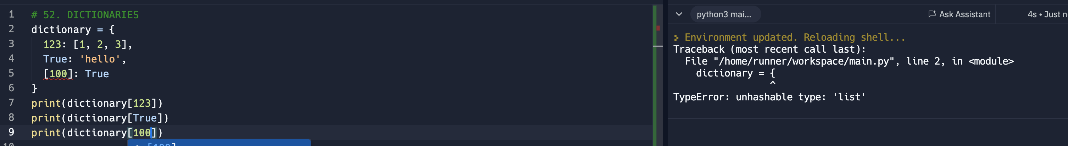
    3. Keys need to have special property. A key needs to be **immutable**. Key cannot change
    4. The 3rd print throws an error because [100] is a list and list is mutable
    5. The key should be unique
       1. 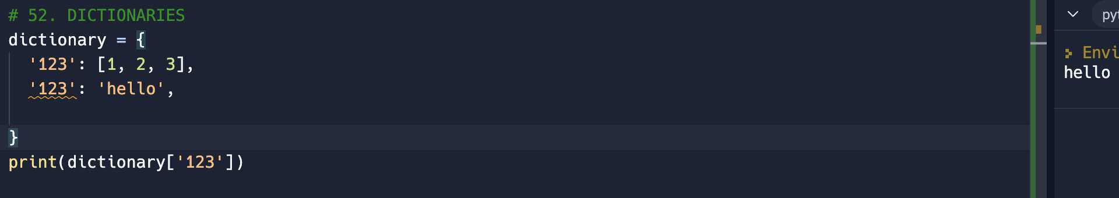
       2. Above, the first ‘123’ was replaced by the 2nd ‘123’ which has a value of ‘hello’
14. Dictionary Methods
    1. 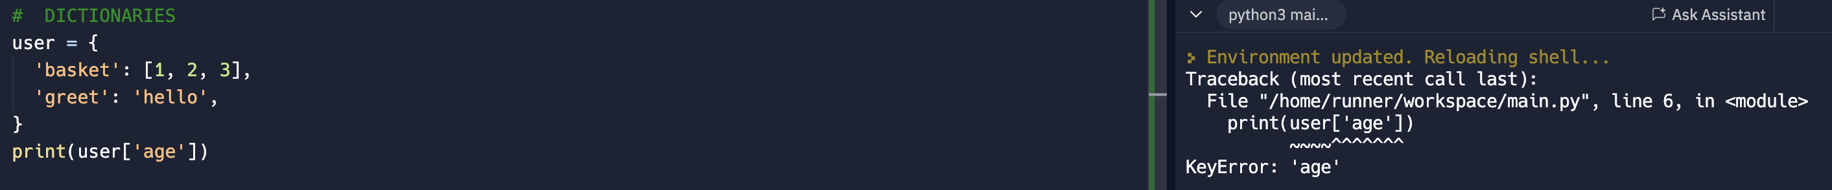
    2. Above check if the key is present in the dict and an error was thrown. The program will not proceed.
    3. Need to eliminate this error. A method to address this is the use of .get so that it will throw ‘None’ which is not an error
    4. .get is a method of the dict
    5. 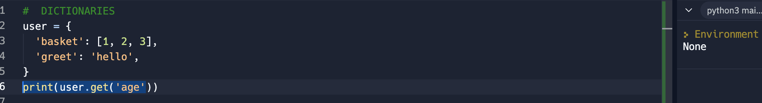
    6. 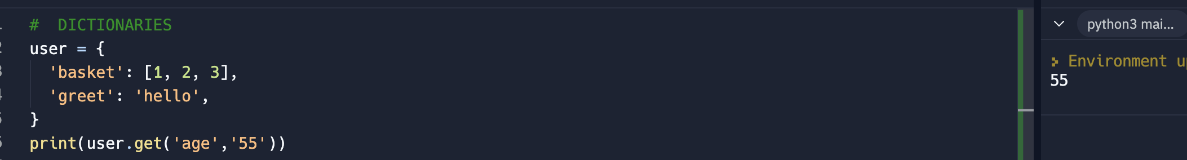
    7. Above syntax is a sample to assign value to age if it is not available. It will retain the original value if it is presence and will not be overwritten (see below)
    8. 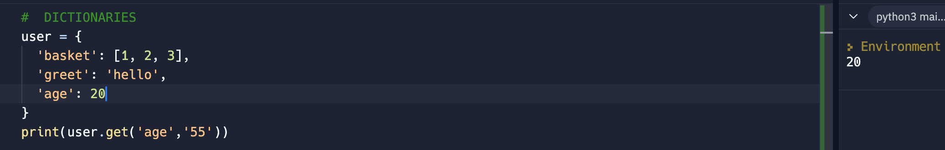
    9. Another way of creating dict, see below
    10. 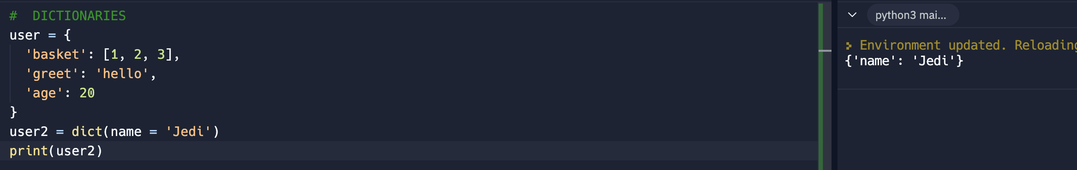
15. Dictionary Method 2
    1. Another way of finding key in a dict
    2. 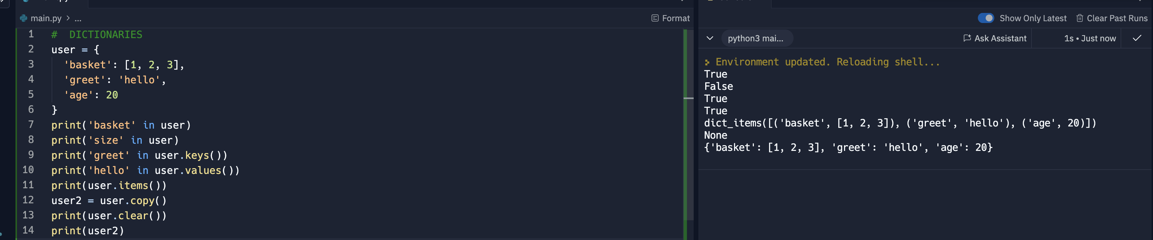
    3. 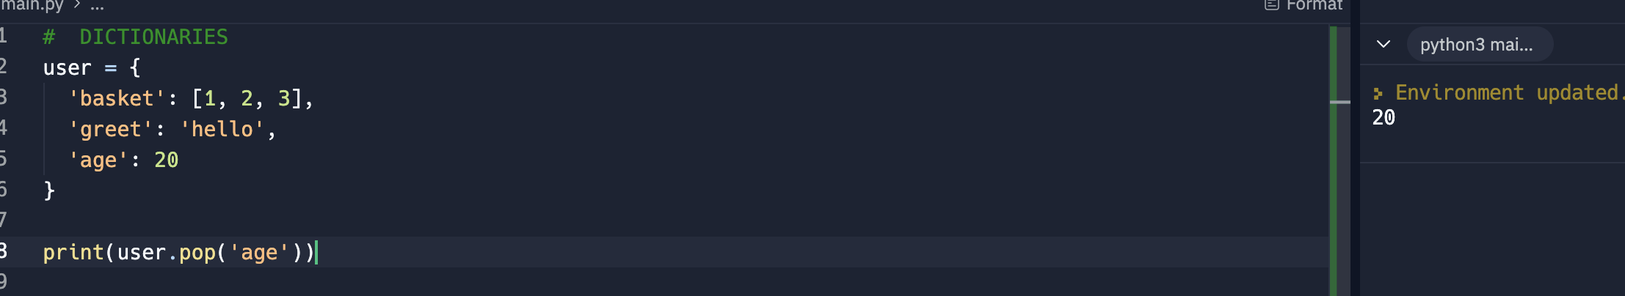
    4. .pop returns the value of what was removed
    5. 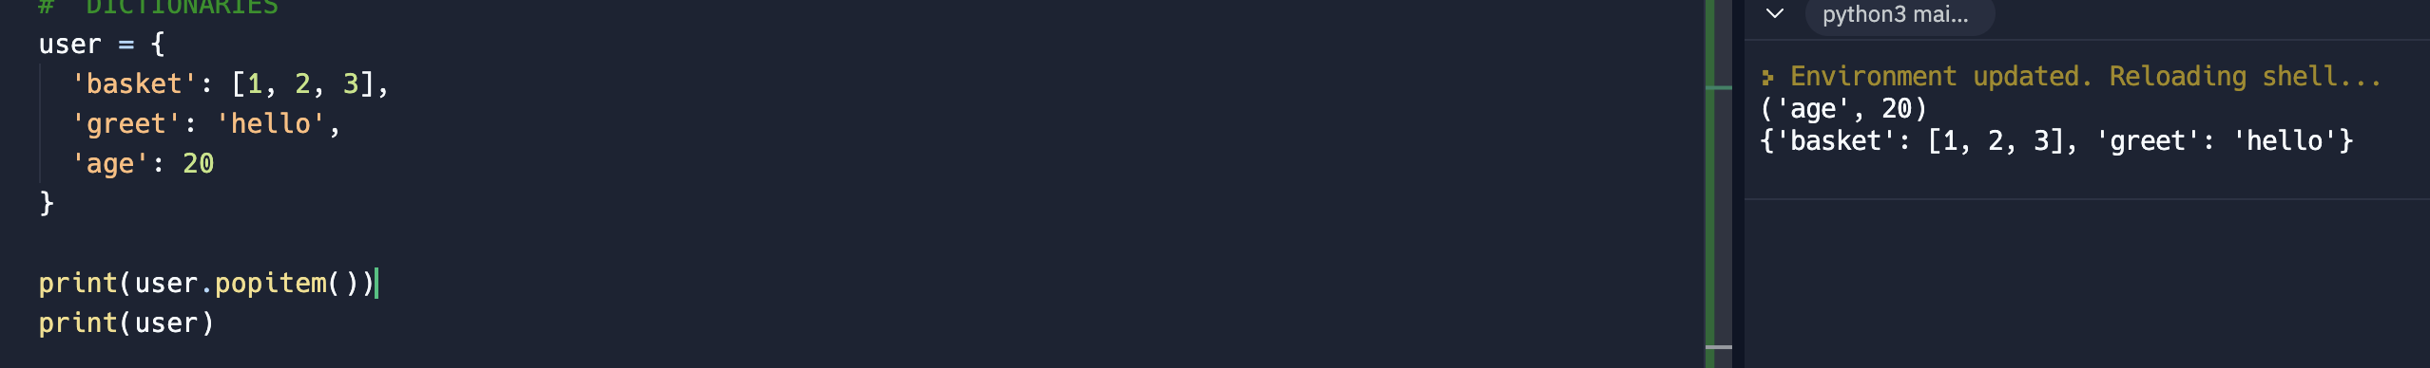
    6. .popitem randomly removed item in the dict. In above case is the (‘age’, 20). Phyton 3.7 it popped now the last key-value pair
    7. 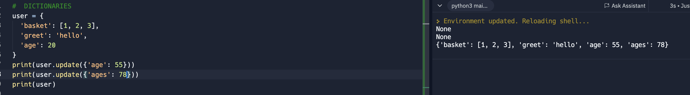
    8. .update, just update the dict with a new value.if the key doesn’t exist like the above sample ‘ages’, it will still be added.
16. Tuple – another data structure
    1. Are like list but its immutable
    2. Data are surrounded by ()
    3. 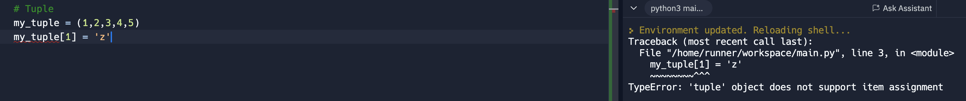
    4. Above sample shows an error because tuple is immutable
    5. 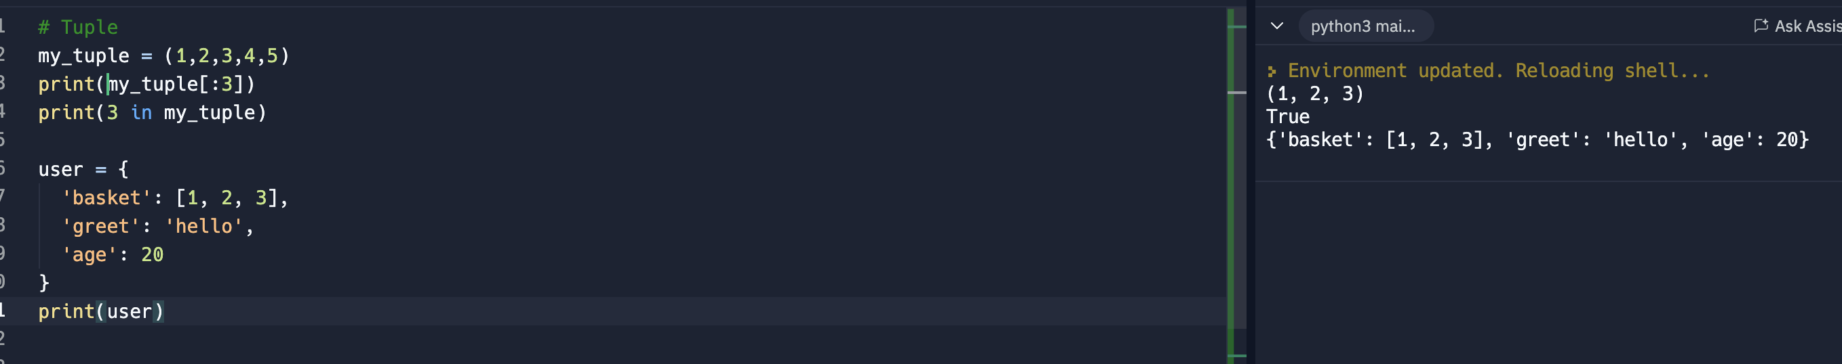
    6. Above shows how to access the tuple. The 3rd print shows that the items in the dict are tuple because the keys are immutable
17. Tuples 2
    1. <https://www.w3schools.com/python/python_ref_tuple.asp>
    2. 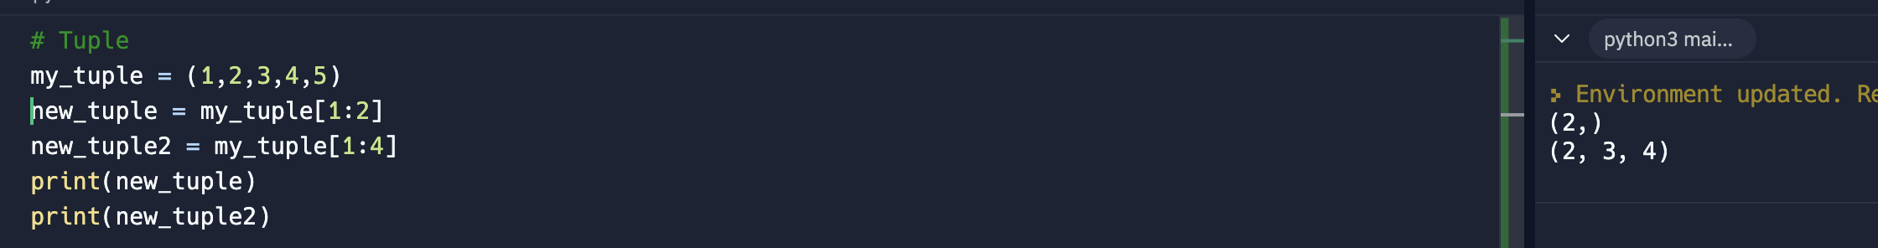
    3. Tuple got only 2 methods. Count() and index()
    4. 
18. Sets
    1. Unordered collection of unique objects
    2. Data are contained within {} like dict but without key-value pairs. It only got values
    3. It has no duplicates, all are unique
    4. On the 1st print, only one 5 was returned
    5. On the 2nd print, 2 was not added because it was already included in the data
    6. 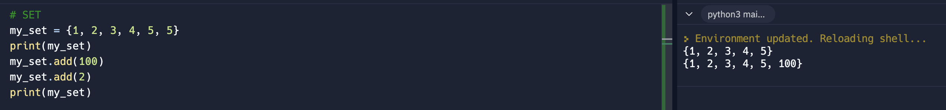
    7. In below sample, a list was converted to set by the use of set(). Upon conversion, the set now did not return the two 5s in the dataset as its now a set and no longer a list.
    8. Very useful for applications that requires usernames and duplicate email
    9. 
    10. In set, data can’t be access by indexing like print(my\_set([0])). It can be accessed like the dict, by the value or item. 1st print is how to access the item. 2nd print is checking the length of the set. Notice that it only count for 5 not 6. Because it did not ocunt the 2nd 5.
    11. 
    12. Set can be converted to list as below
    13. 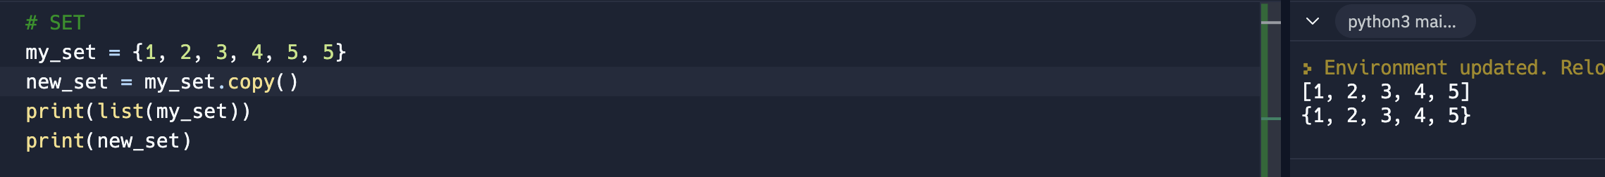
    14. Use of .copy() and .clear(). My\_set was copied and the new\_set is another set. After clear, the my\_set becomes empty set()
    15. 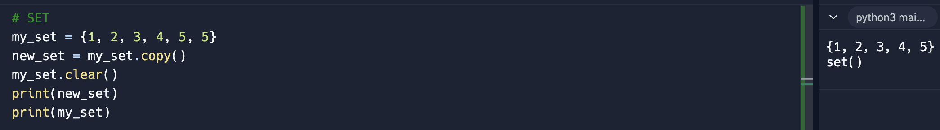
19. Sets 2
    1. Sets methods - <https://www.w3schools.com/python/python_ref_set.asp>
    2. First print. It only retuned the difference between the 2 sets. The duplicates were ignored
    3. 2nd and 3rd print are for discard. It returned None after it discard 5. Then it was removed or discarded from the set
    4. 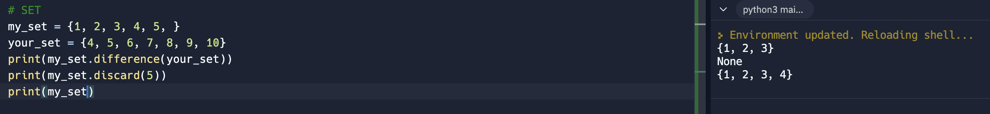
    5. The difference\_update removes the similar values. Unlike difference, this remove the similar values and update the set
    6. 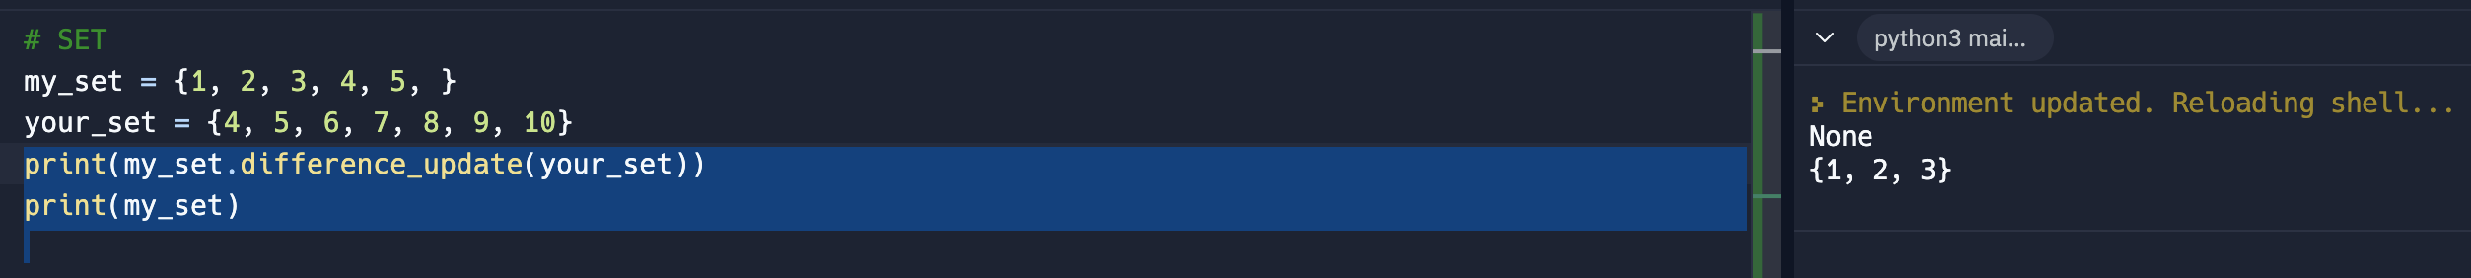
    7. Intersection returns the similar value between sets. Similar tp my\_set & your\_set syntax
    8. 
    9. .isdisjoint is checking whether there’s common values in between 2 sets. Return False if there is and return true if none.
    10. 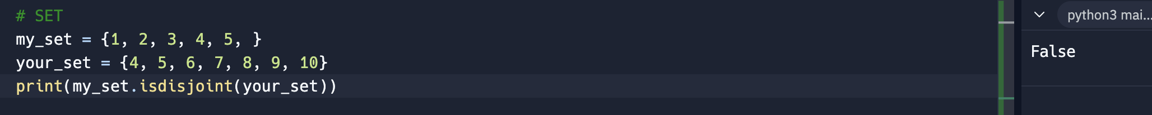
    11. .union – combine the items of the 2 sets without the duplicates and return a new set. Similar to syntax my\_set | your\_set
    12. 
    13. .issubset checks if the entire my\_set items is inside the items of your\_set. Returns true or false
    14. 
    15. 
    16. .superset – literally which is bigger set.
    17. 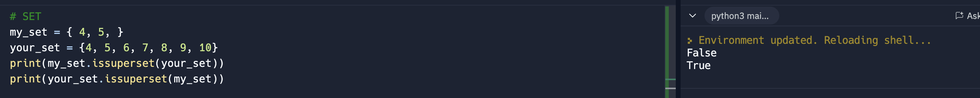

=================================================== End of Data Structures =================================================

Section 4 – Phytpn Basic II

1. Breaking the Flow
   1. 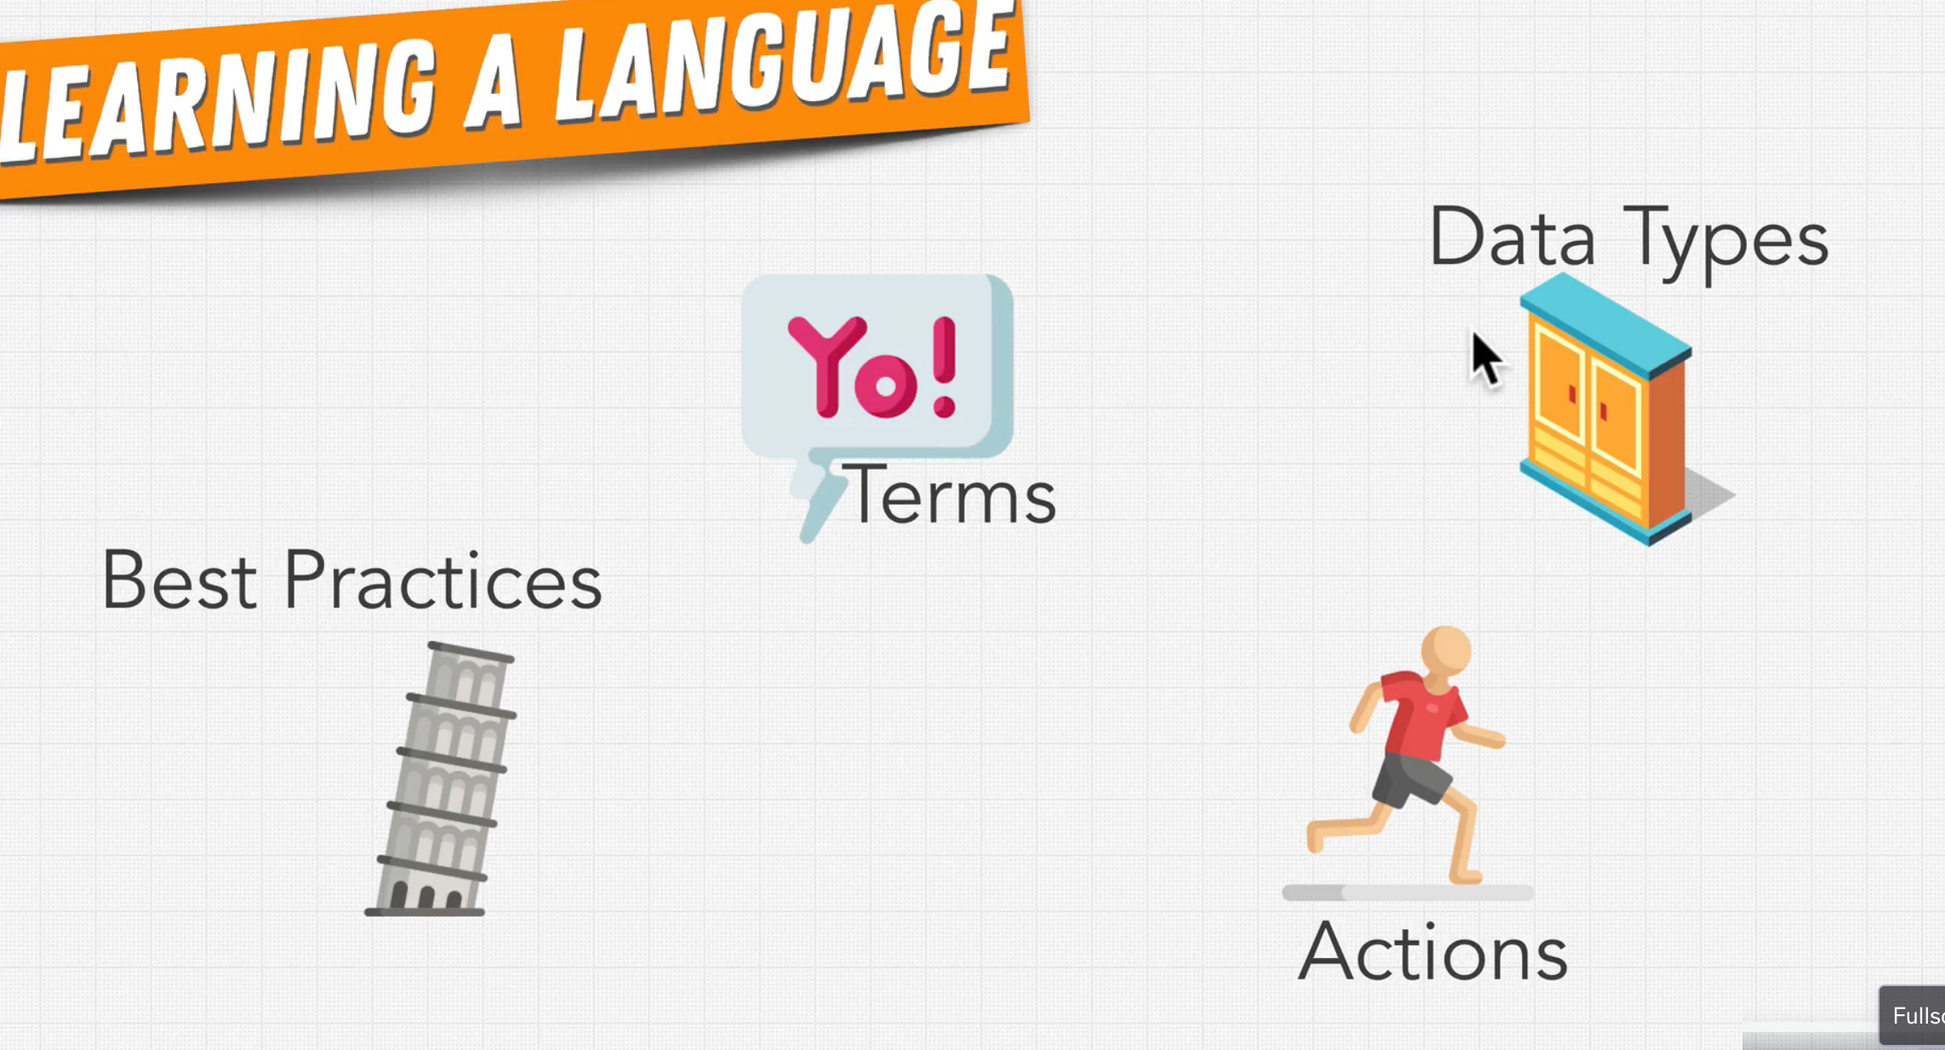
2. Conditional Logic
   1. Utilize the if- elif and else keywords
   2. 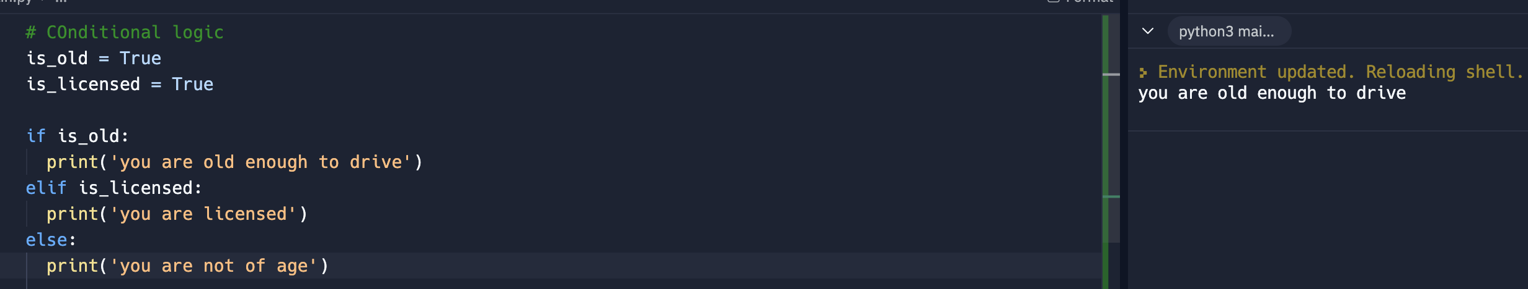
   3. The phyton interpreter will run only the indented code after each if, elif or else.
   4. 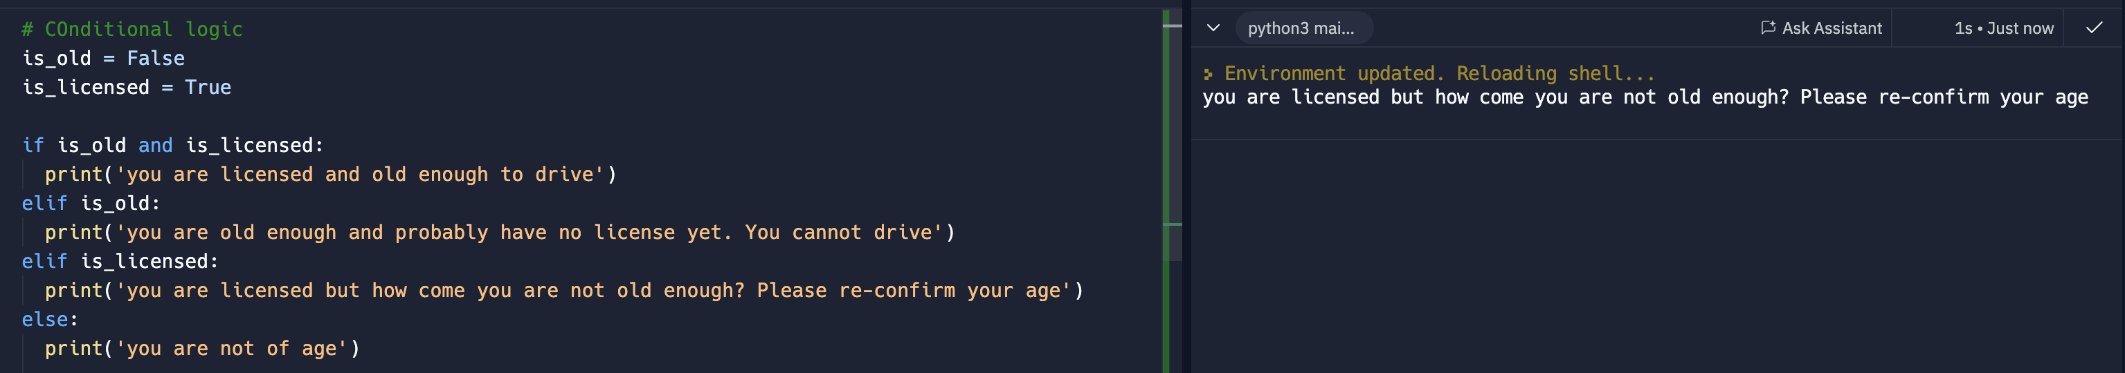
   5. Above shows more complex situation
3. Indentation in Phyton
   1. See sample above. There’s an indentation after the keywords if, else, elif
   2. Interpreter find meaning in the spaces or indentation
   3. Can use 4 spaces or tab if it did not indent automatically
4. Truthy vs falsie
   1. Truthy or falsie values - <https://stackoverflow.com/questions/39983695/what-is-truthy-and-falsy-how-is-it-different-from-true-and-false>
5. Ternary Operator or Conditional Expressions
   1. It evaluates to a value
   2. Similar to ternary operator of JS
   3. 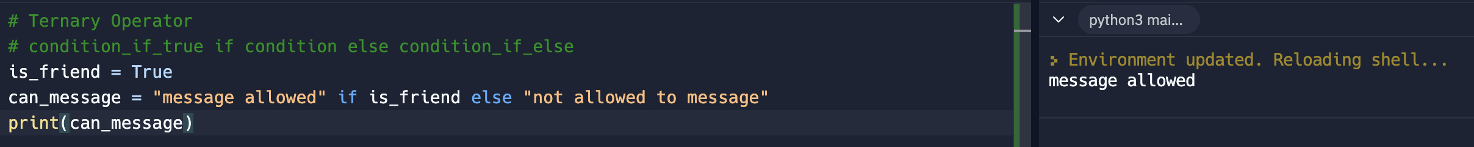
6. Short Circuiting
   1. Can be use if keywords like and or or are use
   2. Use of and requires two conditions to be true before it performs the code
   3. Use of or requires only one condition to be true before it performs the code
   4. 
7. Logical Operators
   1. and, or, >, <, == (need to use two == because the interpreter will see single = as expression,
   2. 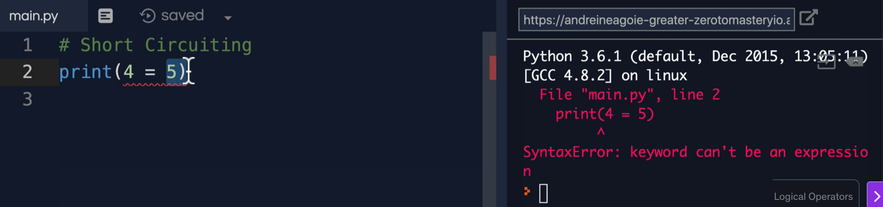
   3. != evaluate if values are not equal
   4. >=, <=
   5. Not – is a keyword and at the same time a function to get the opposite of the value. In below it returns false even though 1 == 1
   6. 
8. Exercise: Logical Operators
   1. See code below. And not is more appropriate to be use than or because if is\_magician is true then the whole expression will just be turn into true.
   2. 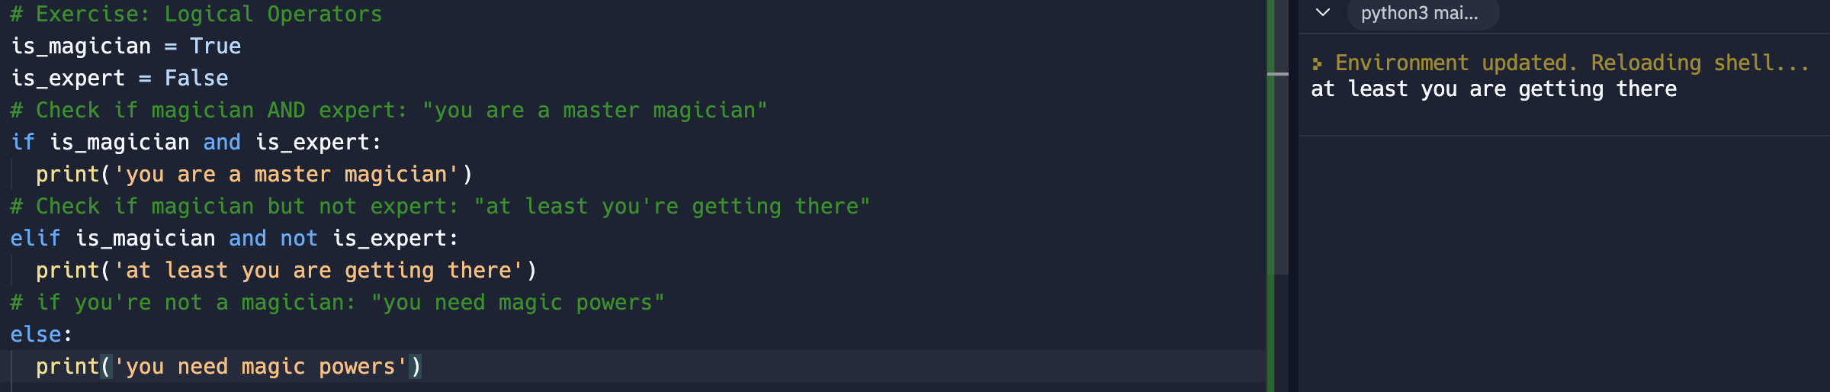
   3. Another way to write this code is as below as per ZTM which is better because it evaluates and check the condition if is\_magician is false. My code did not do this
   4. 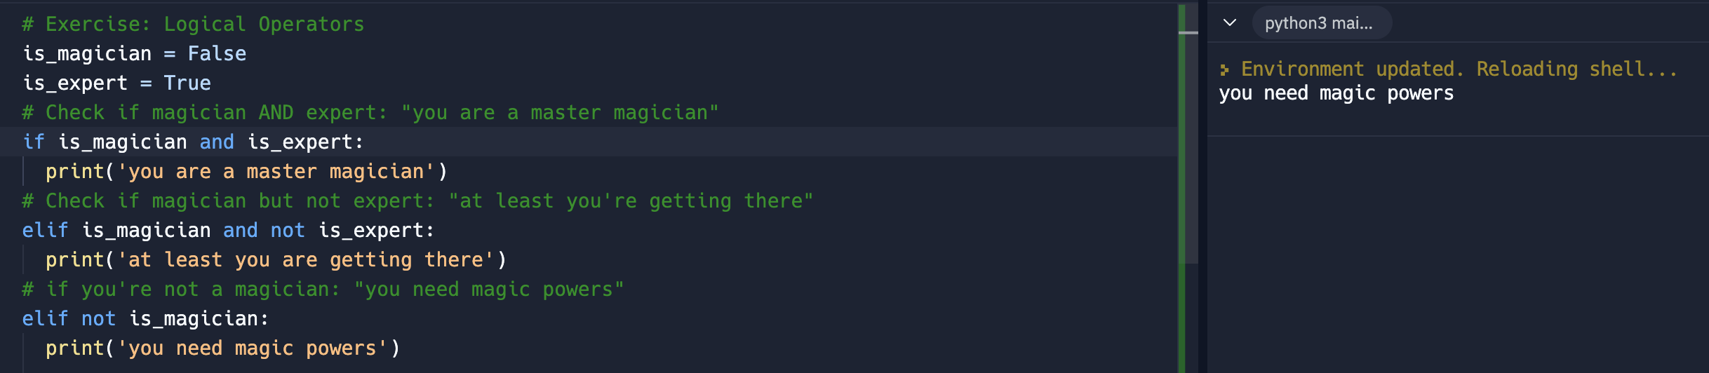
9. Is vs ==
   1. == checks the equality of 2 values
   2. 1st print returns true because the interpreter will convert 1 to bool(1) because True is a Boolean
   3. 4th print one of each value will be converted by interpreter either to int or float and vice versa thus resulting to true
   4. 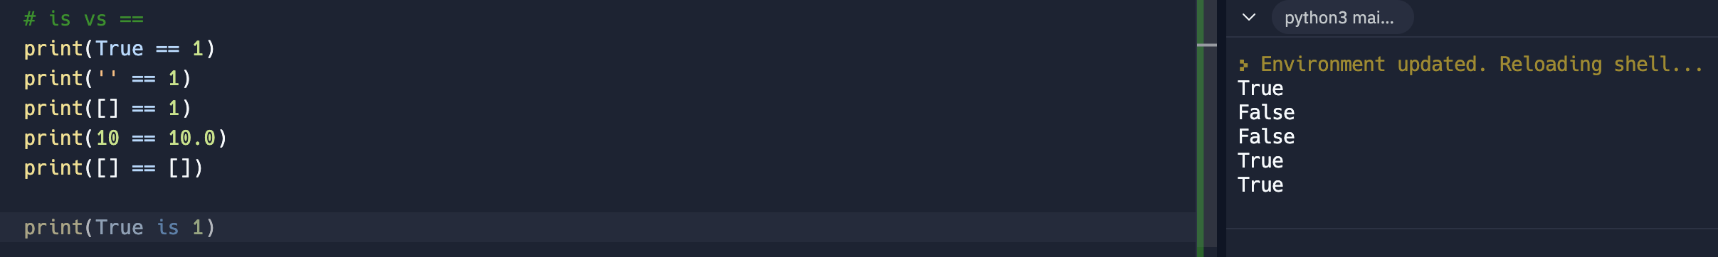
   5. Is check if the location in the memory where the value is stored is the same
   6. More strict, looking for the very exact value
   7. 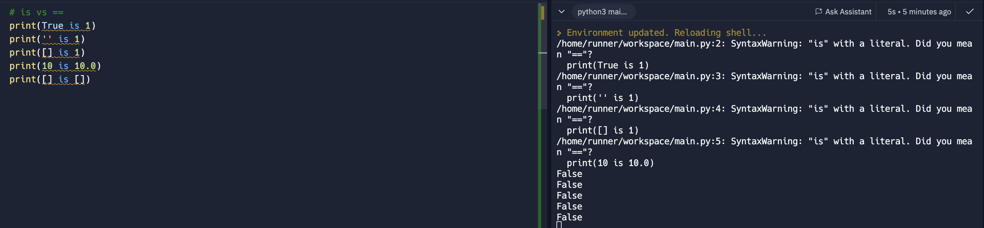
10. Loops
    1. for item in ‘Zero to Mastery’: – item is just a variable, it can be anything. This variable is created for each item in ‘Zero to Mastery’, do something.
    2. ‘Zero to Mastery’ is iterable. Iterable is something that can be loop over
    3. Looping can be use in strings, list, set and tuple/
    4. For Loops allow to allow to iterate over anything that has a collection of items
    5. 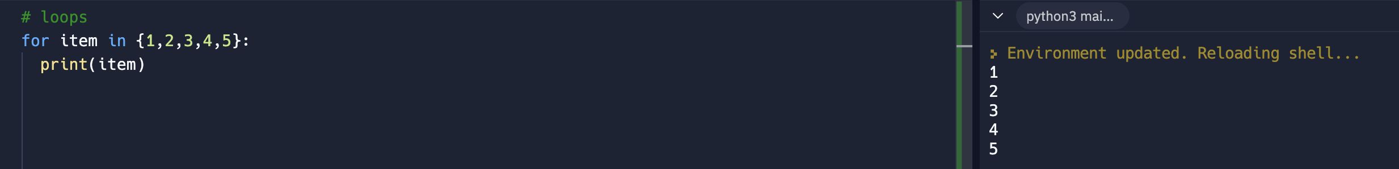
    6. 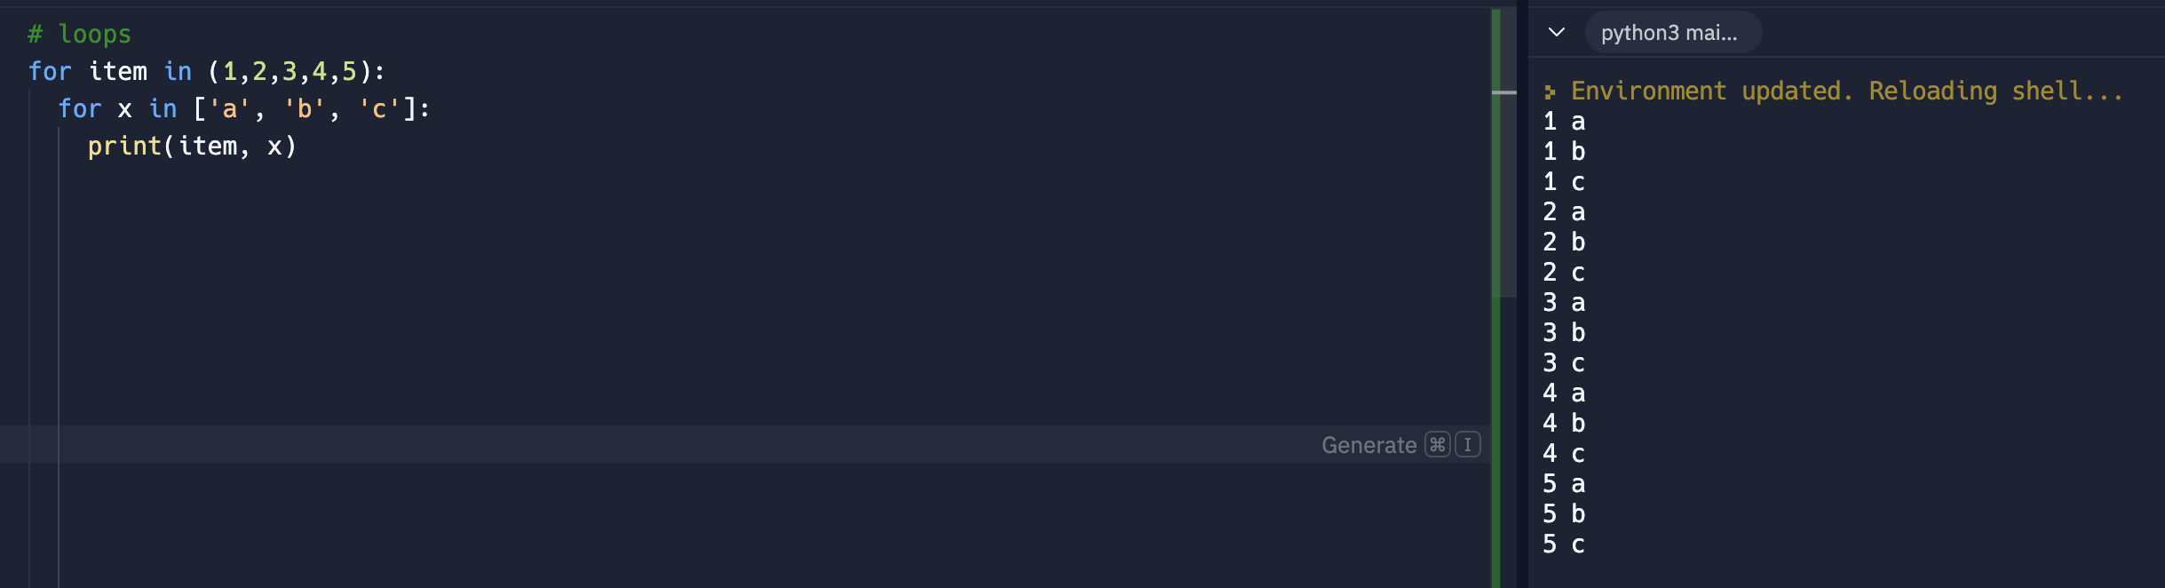
11. Iterables
    1. It can be list, set, dict, tuple and strings
    2. It check one by one for each item in the collection
    3. Iterating or looping into something
    4. Below is how to get the keys
    5. 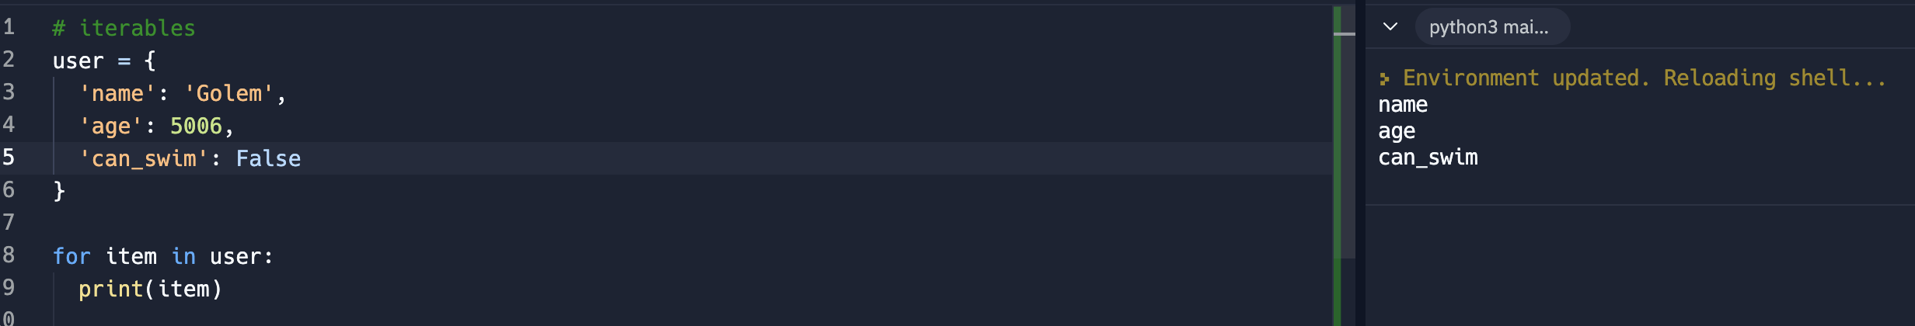
    6. Methods for dict. These are the most common methods that can be use with dictionaries
       1. .items
       2. .values
       3. .keys
       4. 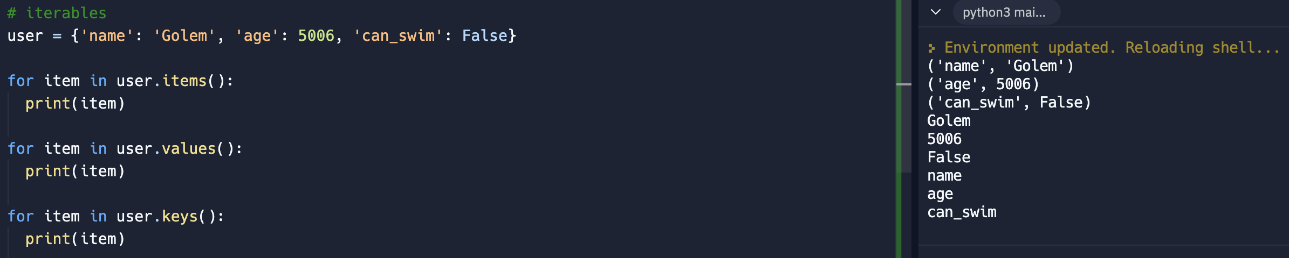
       5. Other Patterns:
          1. 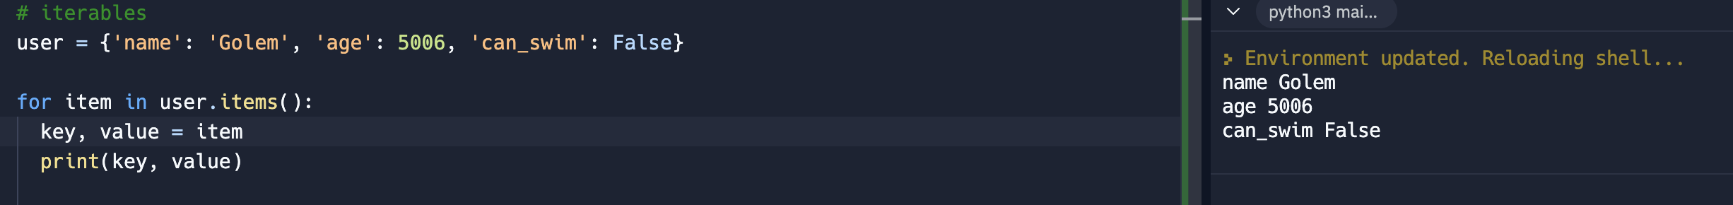
          2. 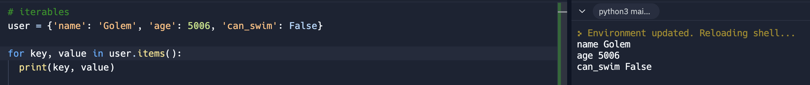
12. Exercise: Tricky Counter
    1. Andrei’s code
       1. A variable should be outside the loop, as the loop will run over and over until it finishes all the items
       2. 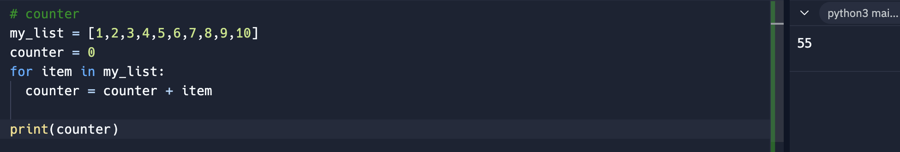
       3. If counter = 0 is inside the loop, it will always reset every time it loops thus the result = 10
       4. 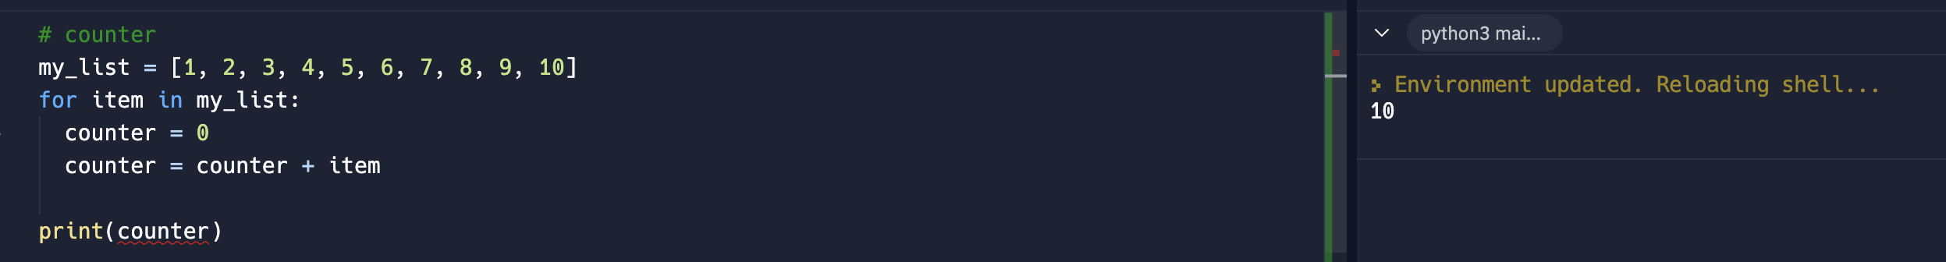
    2. My code
    3. 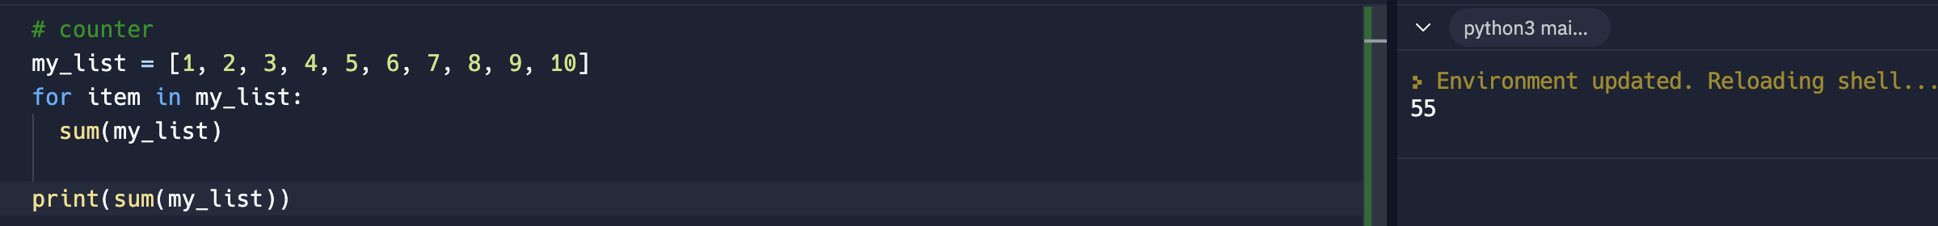
13. Range
    1. Range will allow to iterate as many as mentioned in the range. It’s a special type of object that can be iterated.
    2. 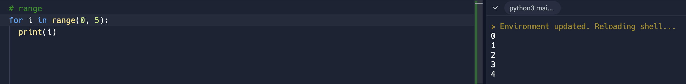
    3. Sample application is sending emails. It can loop to send number of emails base from the loop mentioned in the range
    4. The third integer is the step over
    5. 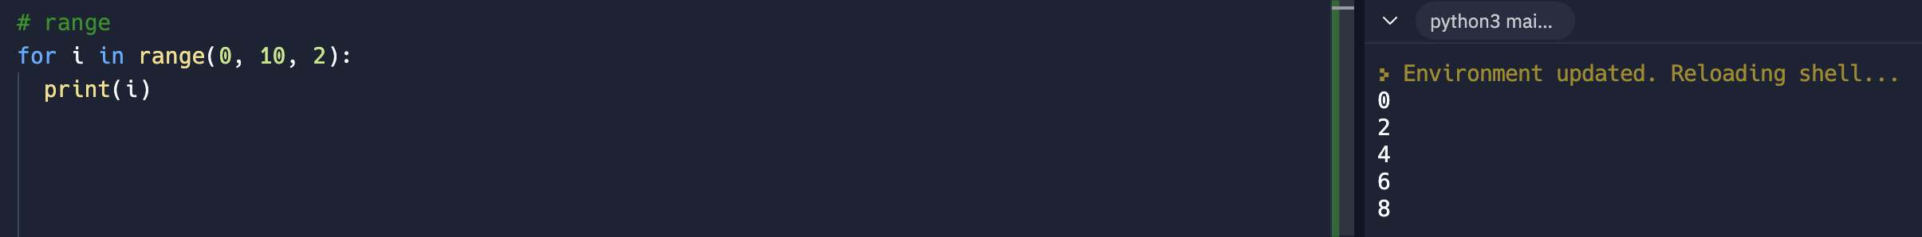
    6. 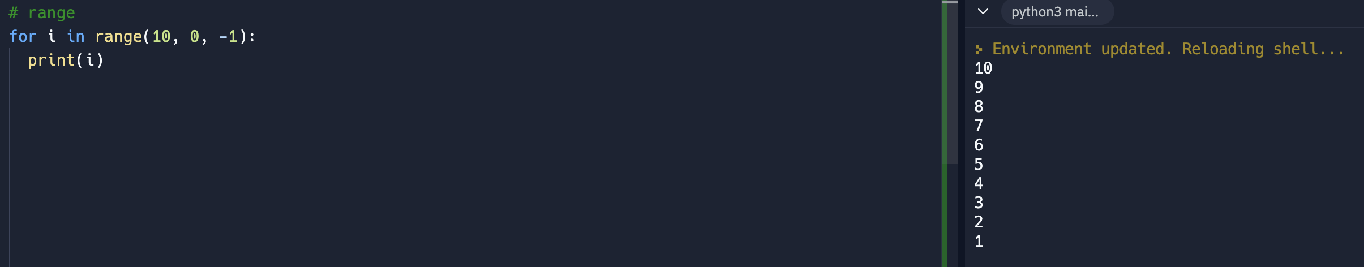
    7. – step over is descending
    8. Another syntax sample
    9. 
14. Enumerate
    1. Returns an enumerate object. Iterable must be another object that supports iteration. Very useful if index counter is needed.
    2. It gives an index counter and the item of the index
    3. 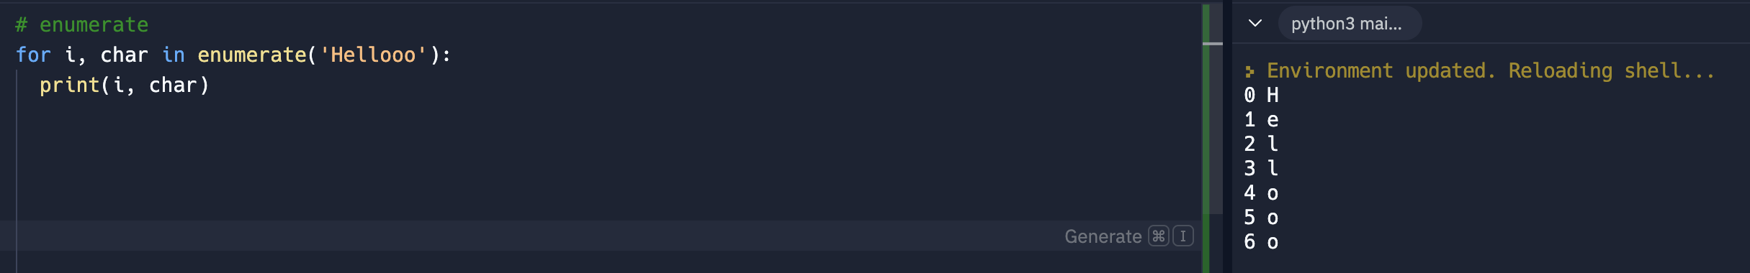
    4. 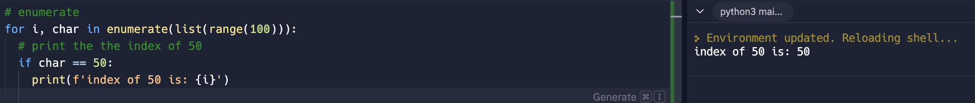
15. While Loops
    1. While loop runs a code while a condition is being met
    2. Be very careful as it might give an infinite loop of code
    3. Sample of an infinite loop code. The below code will continue to run as 0 is always < 50.
    4. 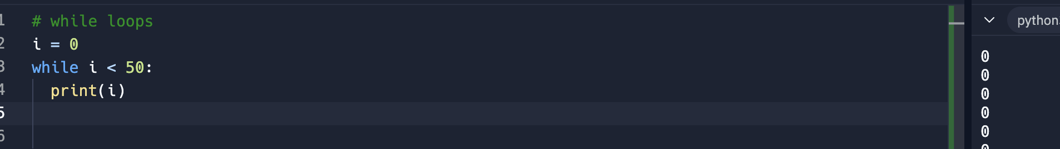
    5. Use of break. A use of break will stop the code to run
    6. 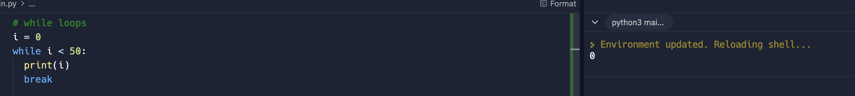
    7. Basic use of while loop. In below sample.
    8. 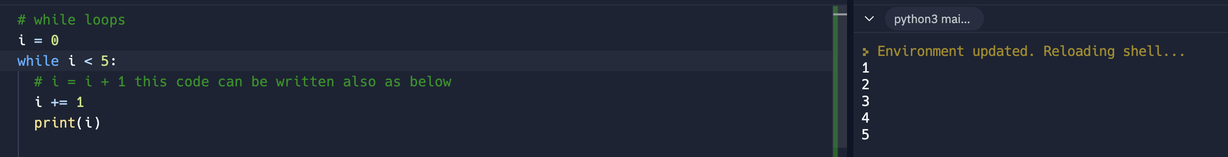
    9. 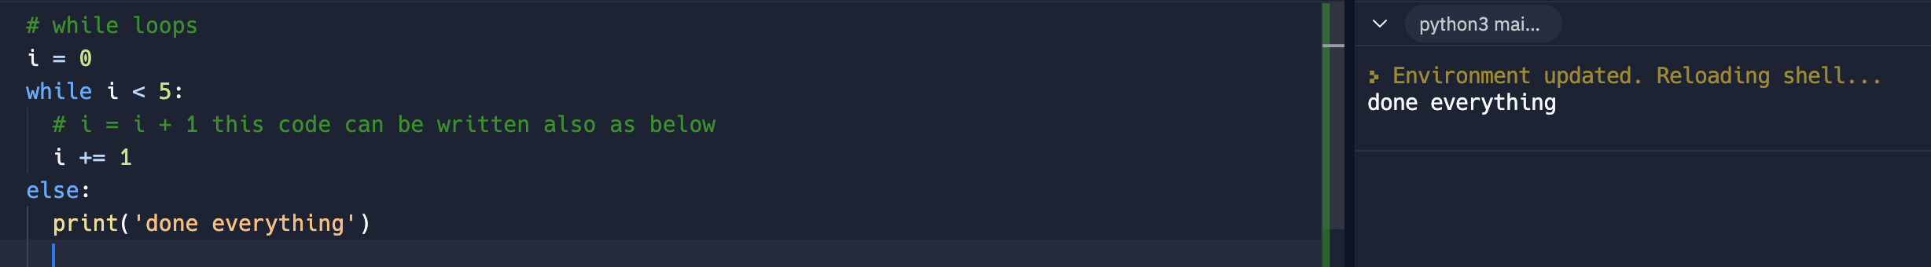
16. While loops 2
    1. For loops are simpler. Use for simple loops.
    2. While loops are more flexible as it accepts condition. Always create the variable (i) and increment it. If the number of loops are unknown.
    3. 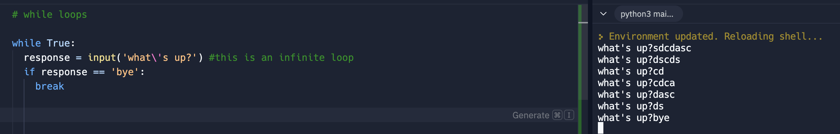
17. Break, continue, pass
    1. Break can be use in both for and while loops. Break just exist the exisiting loop
    2. Continue – it will just return back to the start of the code once it hits the end of the code. In below example, it didn’t print.
    3. 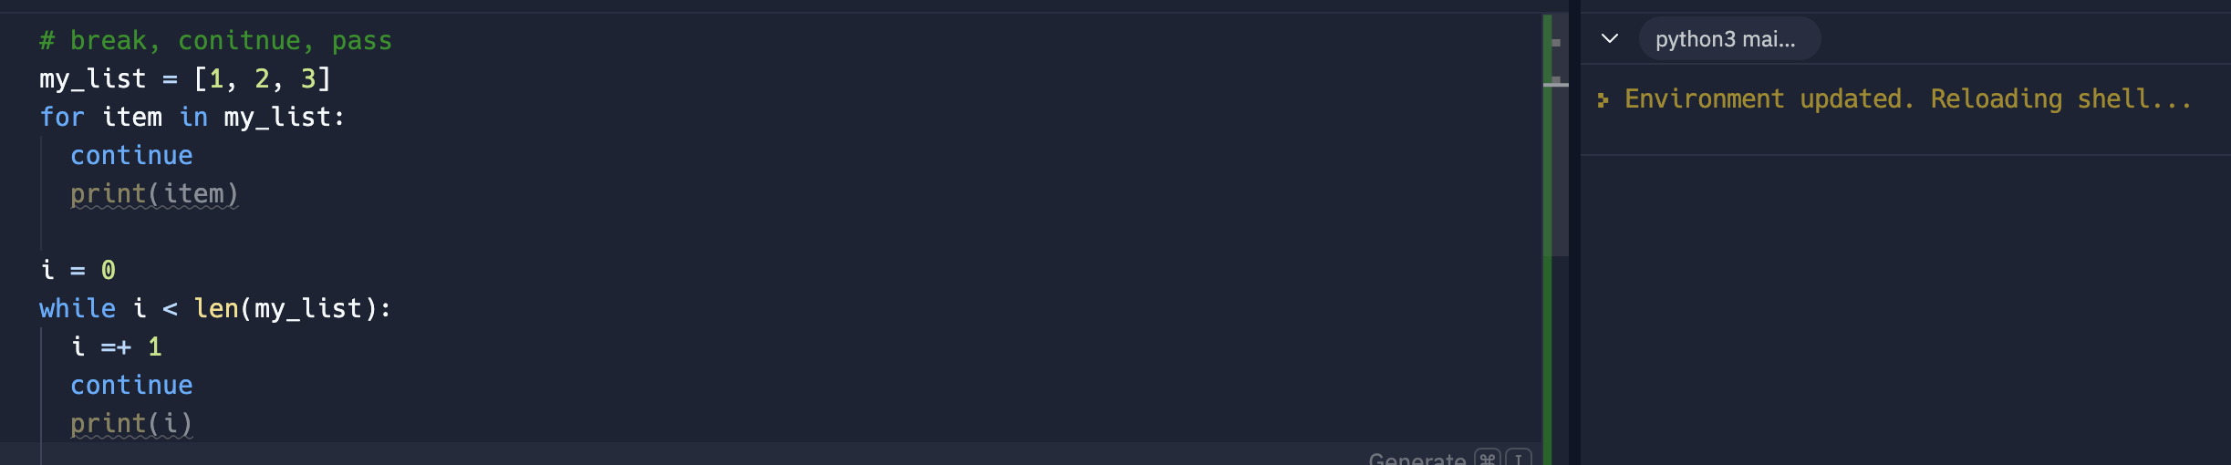
    4. Pass just pass in the next line. Pass can be use as place holder while still developing the final code. It does nothing
    5. 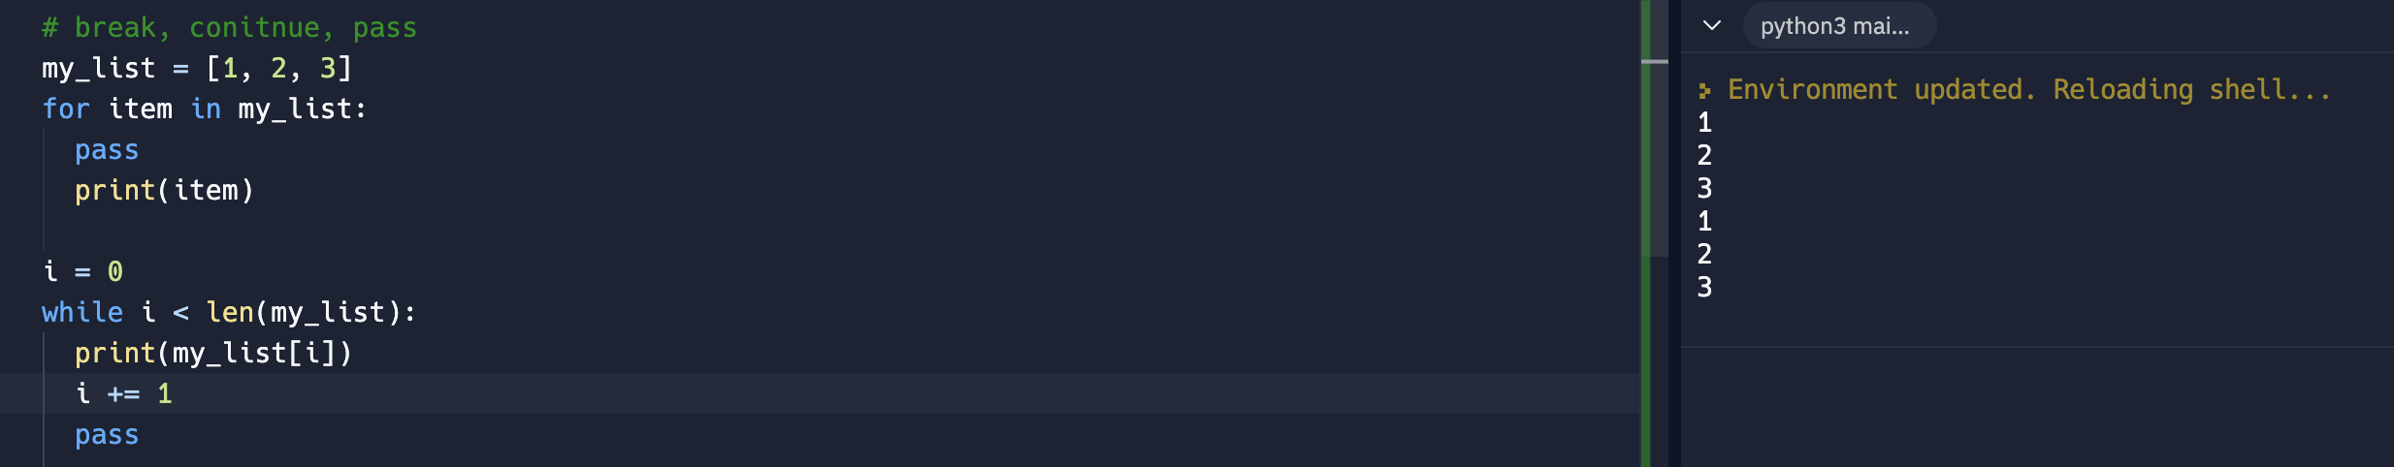
18. First GUI
    1. 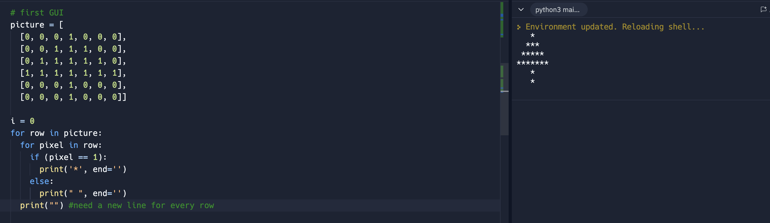
    2. Can be written also as below
    3. 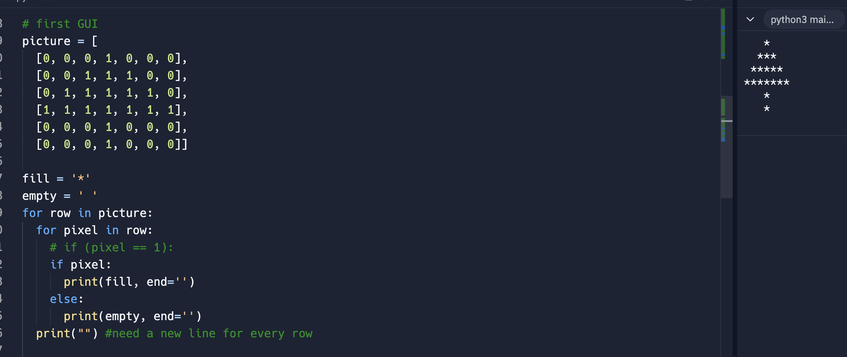
19. Developer Fundamentals IV
    1. What is good code?
       1. Code should be clean and following the standard
       2. Readability; it should be easy to understand
       3. Add meaningful comments
       4. DRY = do not repeat your code
20. Exercise: Find duplicates in a list
    1. 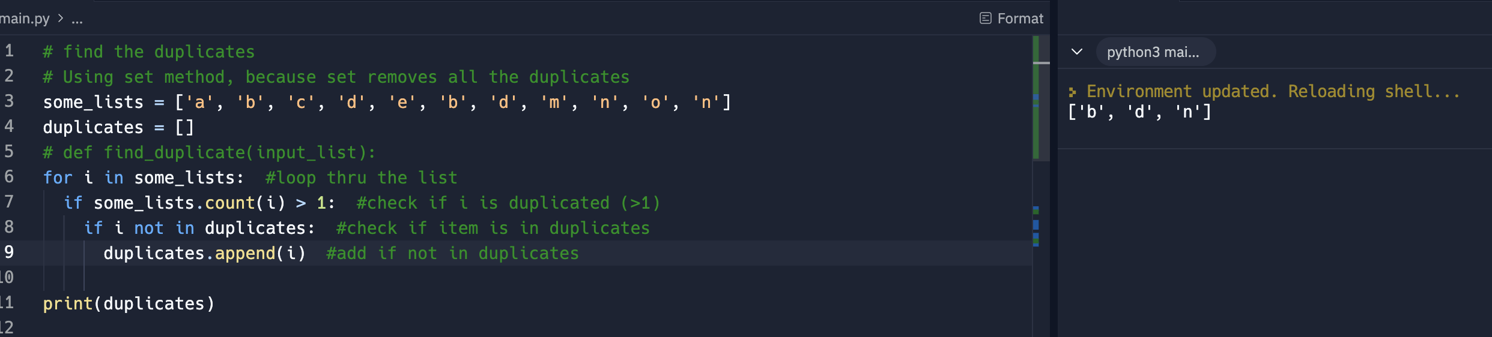
21. Functions
    1. Very important, powerful and existing in all programming languages
    2. Start by using the keyword def function\_name():
    3. Call it by using the parenthesis like function\_name()
    4. Address the DRY issue
    5. In below sample, the show tree\_tree() was run 3 times thus the console displays 3 trees. If no function the whole for loop needs to be run thrice
    6. 
    7. Function should run AFTER the function was created and not before the code
22. Parameters and Arguments
    1. Keywords to define function
    2. Parameters are the variables inside the parenthesis when ***defining*** the function
    3. Arguments are the actual values for provided to each variable when function was ***called or invoke***
    4. 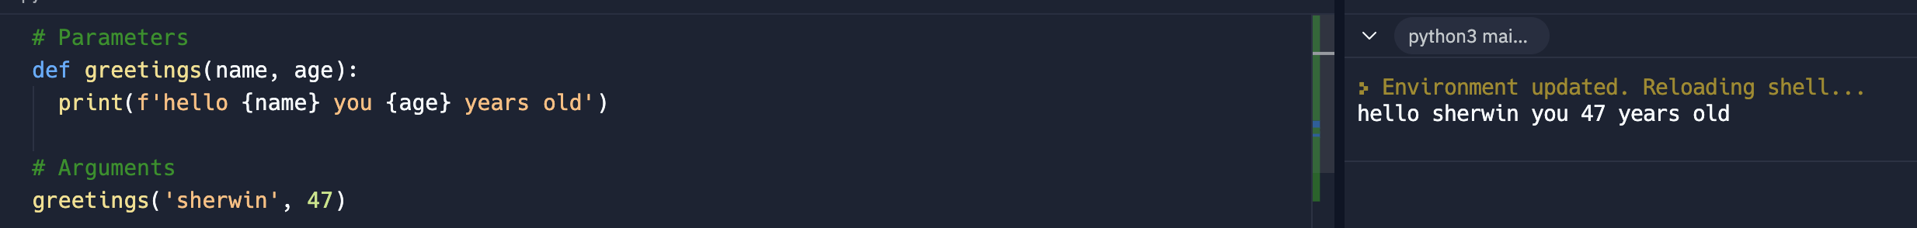
23. Default Parameters and Keyword Argument
    1. 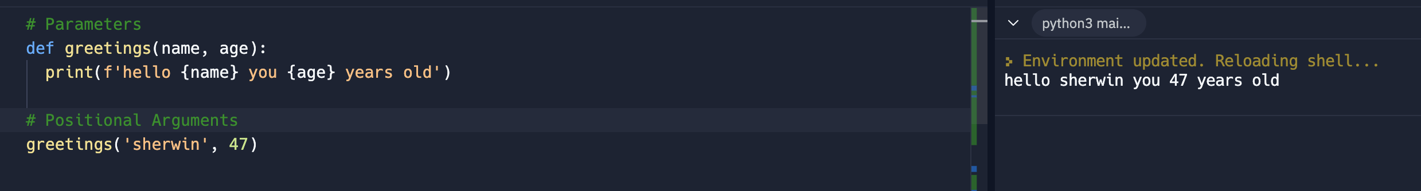
    2. Above is a sample of a positional arguments where the position matters. It requires to follow the position
    3. Keyword Argument – doesn’t require the position but it needs to provide the keyword and value
    4. 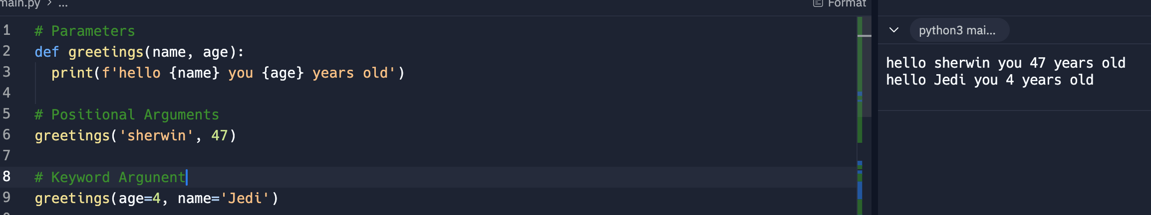
    5. Default Parameters are helpful if arguments are not provided to function, see below
    6. 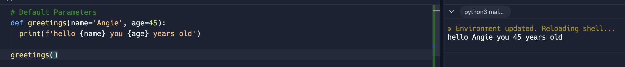
24. Return
    1. It work with function
    2. Functions always return a value
    3. Below sample has no result, as even print was not used.
    4. 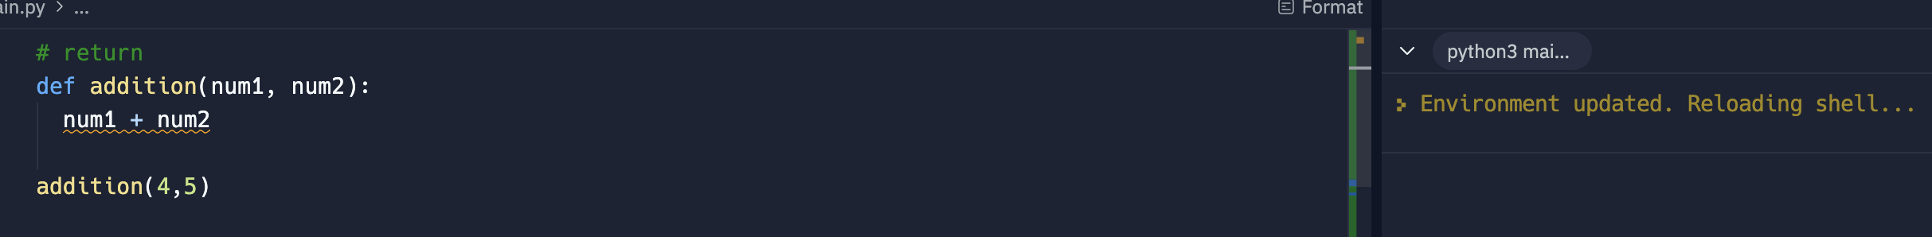
    5. The console displayed None as the function was just printed and the function did not return any value
    6. 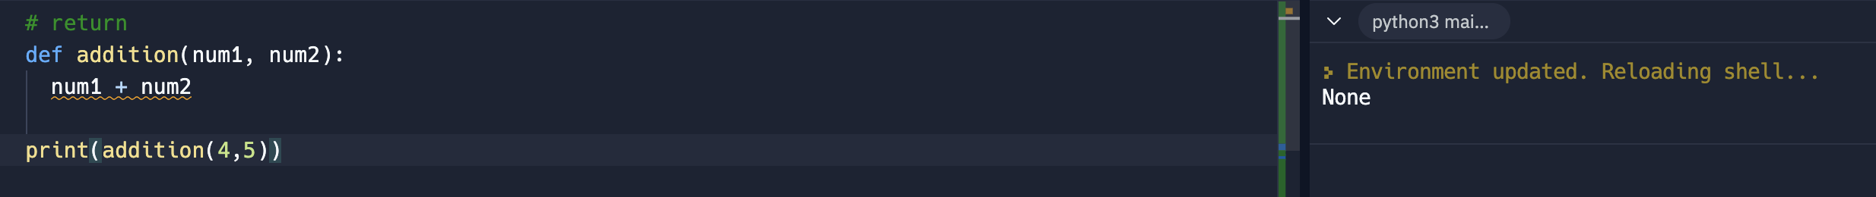
    7. The code now returns a value
    8. 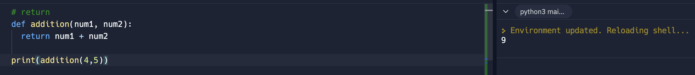
    9. ***Functions either modify a program or returns something***.
    10. Remember:
        1. Function should do one thing really well
        2. Function should return something
    11. Function can return something and the output can be assign to variable
    12. 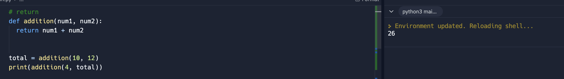
    13. Below function returns None because the def function() only calls the def another\_addition() but did not returned it
    14. 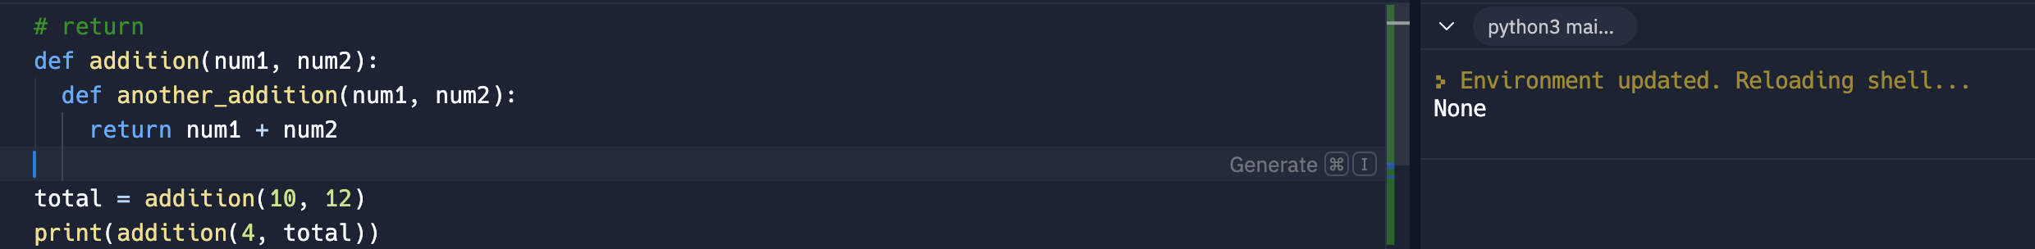
    15. Below is a way to address it.
    16. 
    17. Return automatically stops or exit
25. Exercise: Tesla
    1. 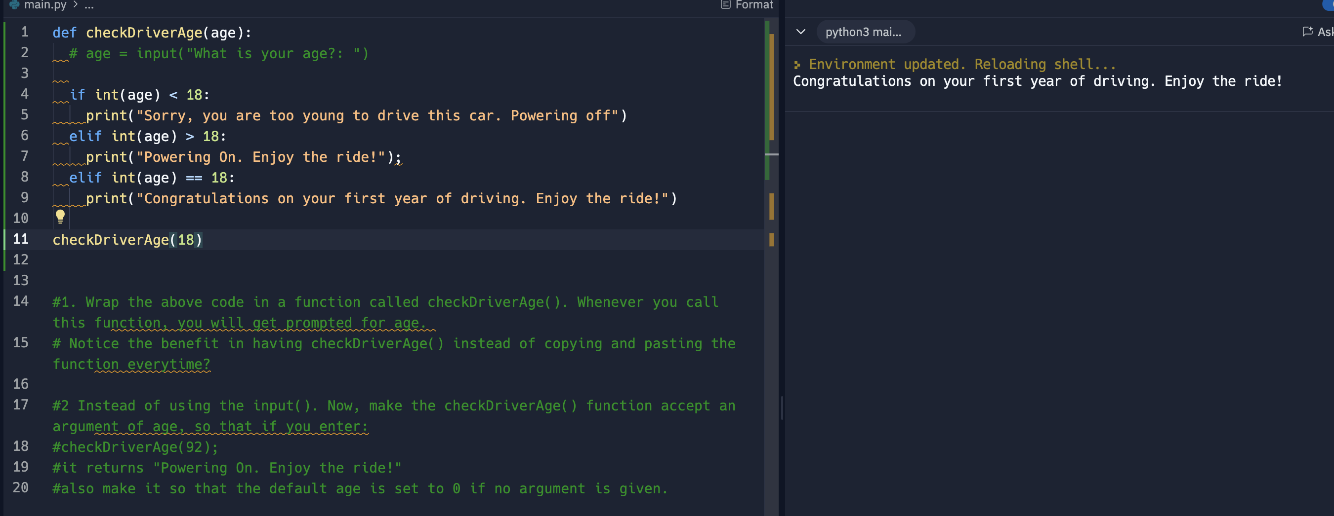
26. Methods vs Function
    1. Methods are invoked by the use of “.” Notation
    2. Methods are own by object or data type. Ie; ‘hello’.capitalize()
27. Docstrings
    1. Enable to write a comment inside the function
    2. 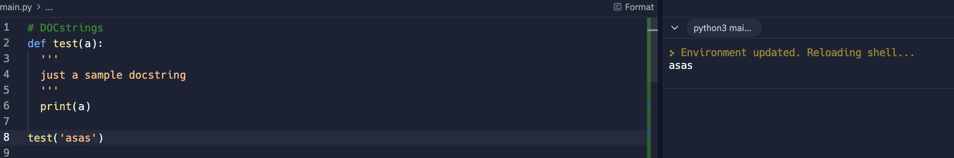
    3. 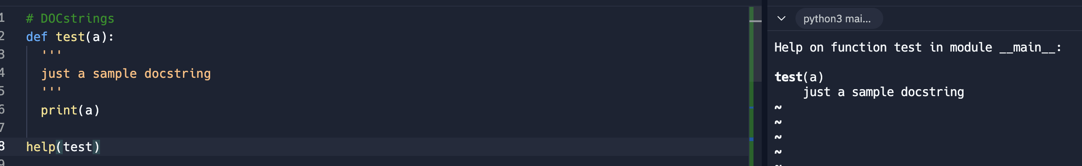
    4. 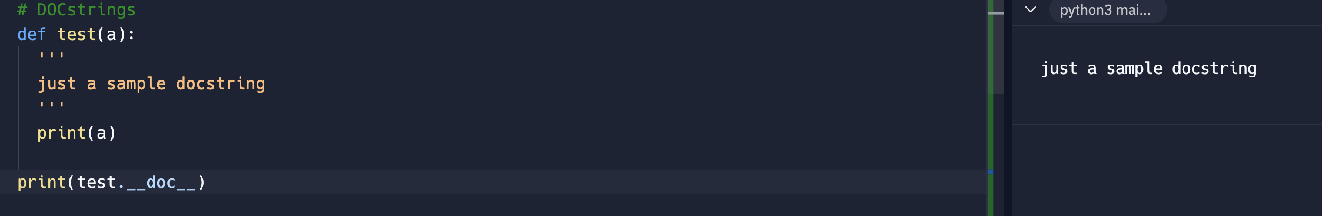
28. Clean code
    1. First possible code
    2. 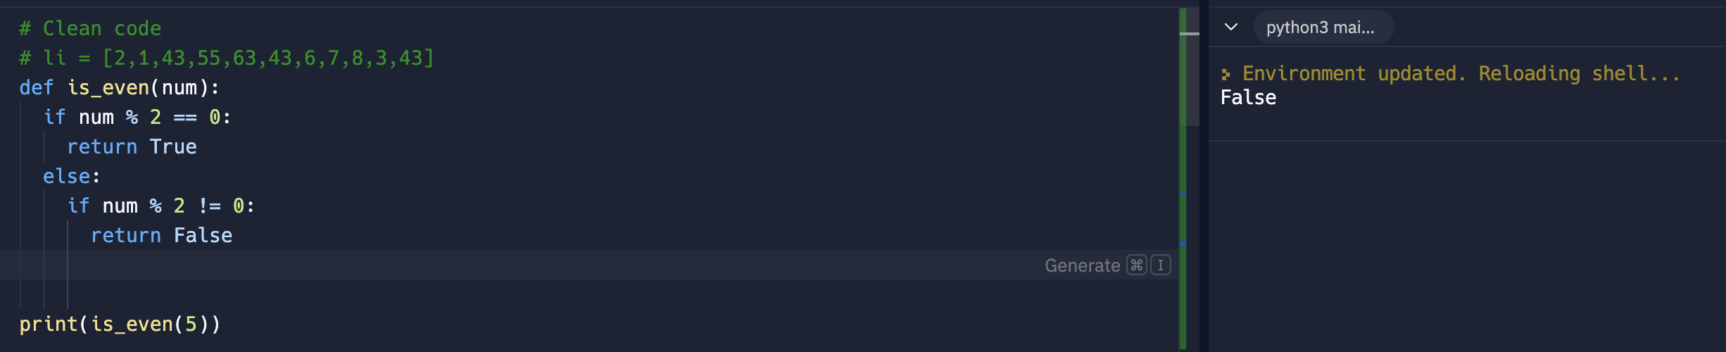
    3. Another way to write the code
    4. 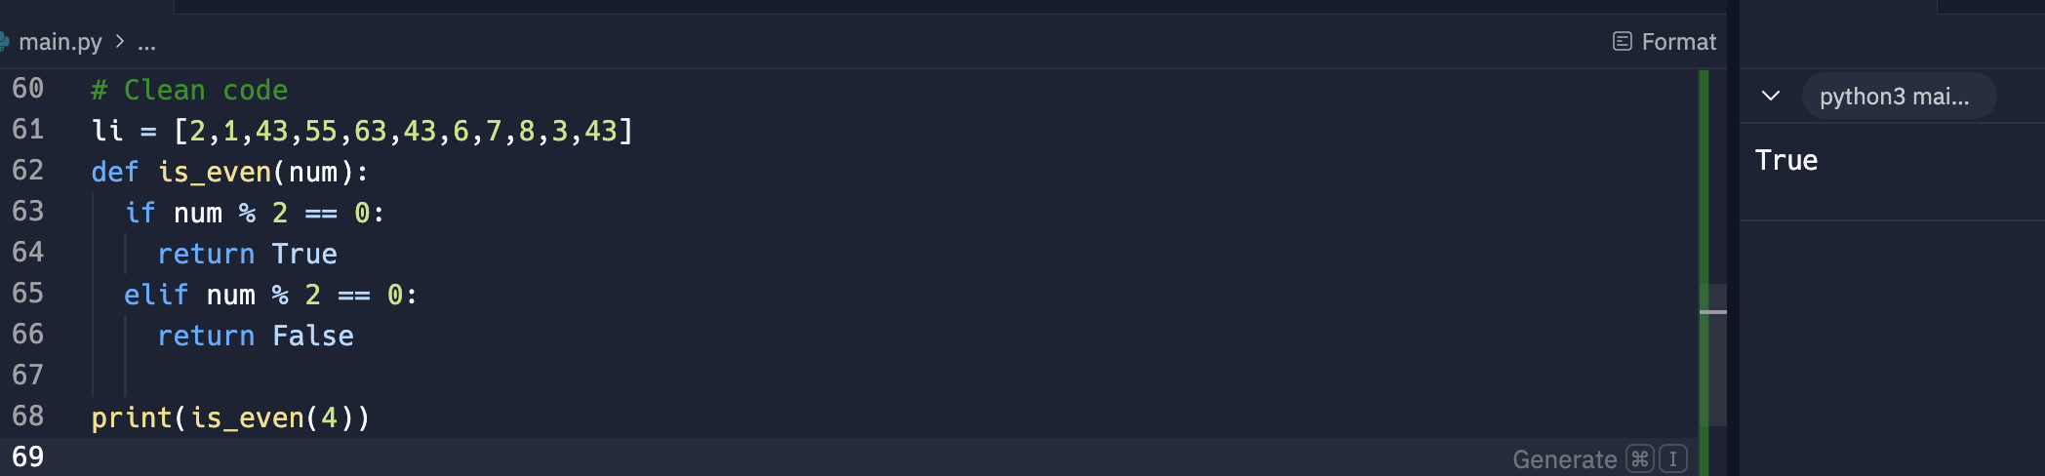
    5. 2nd clean up is by using else. Because the evaluation is just similar to the first one
    6. 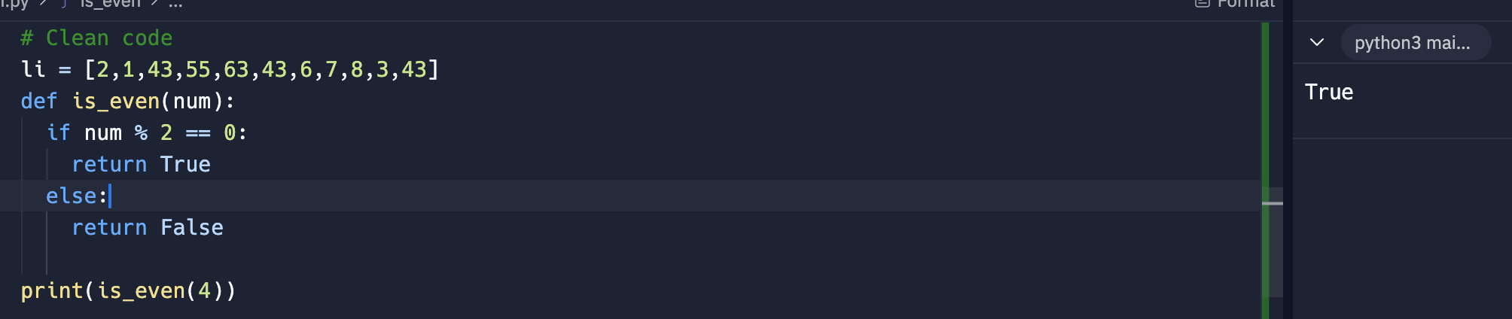
    7. 3rd clean up can remove the else: as the first evaluation will return its result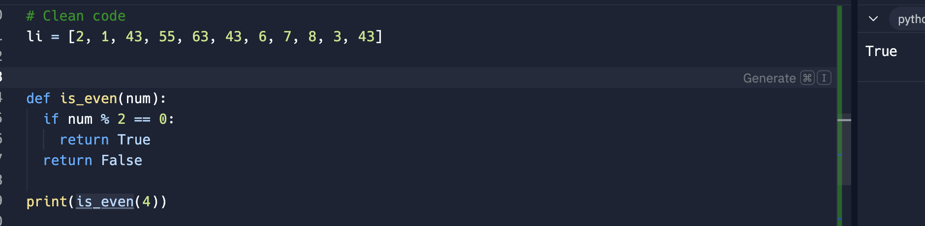
    8. 4th clean up
    9. 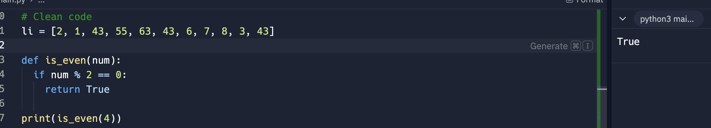
29. \*args and \*\*kwargs
    1. \*args – enable the function to receive multiple positional argument. Produced tuple  
       \*\*kwargs – enables the function to receive multiple keyword arguments. Produced dictionary
    2. Rule is- params, \*args, default parameters, \*\*kwargs
30. Exercise Functions
    1. 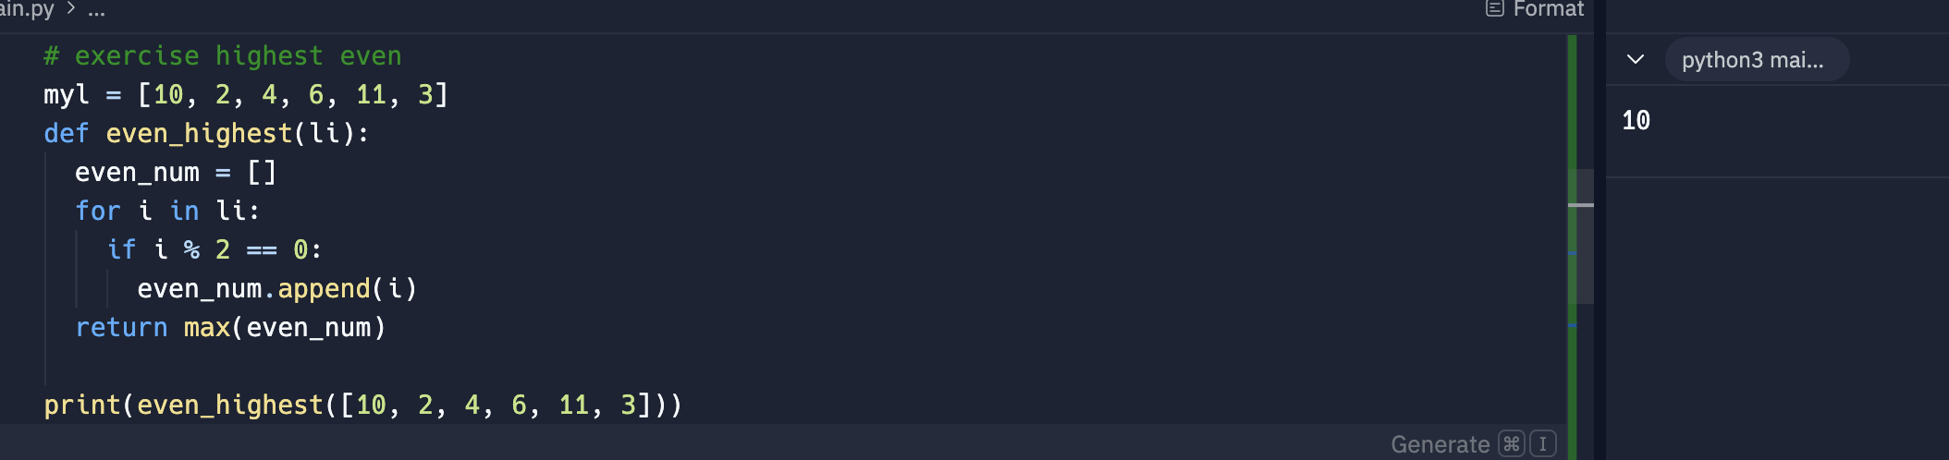
31. Walrus operator - := is a syntax that assigns to a variable in a larger expression.
    1. 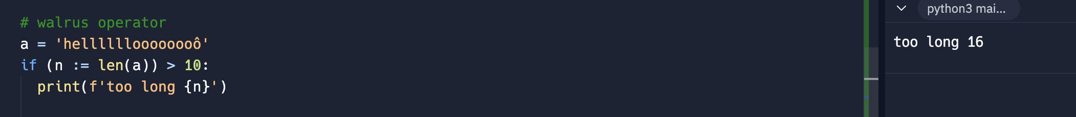
    2. 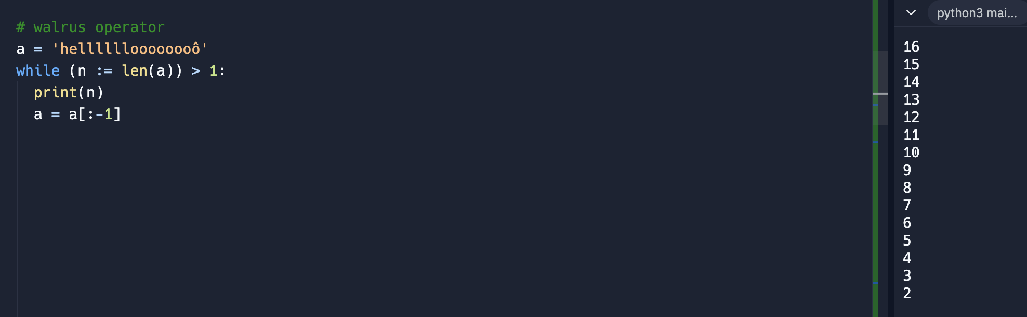
32. Scope – what variables do I have an access to
    1. This shows an error because the print() doesn’t have an access to total variable
    2. 
33. Scope Rules
    1. Local
       1. 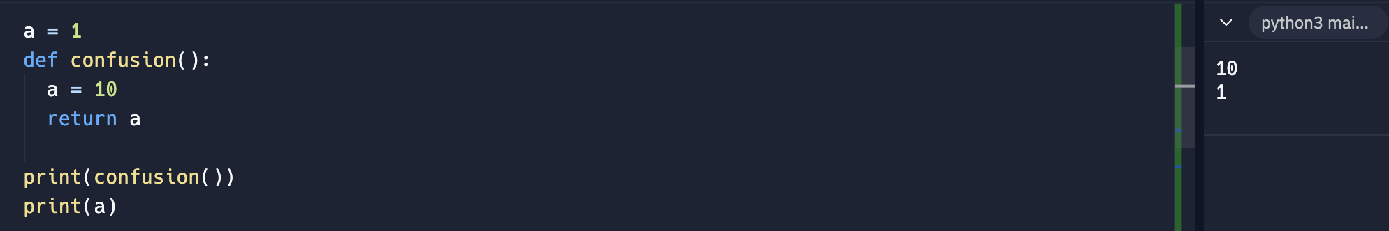
       2. 10 is the output of the parent() and 1 is the output of the print(a). 1 is from the a= 1 while the 10 is from local variable a = 10
    2. Parent local
       1. 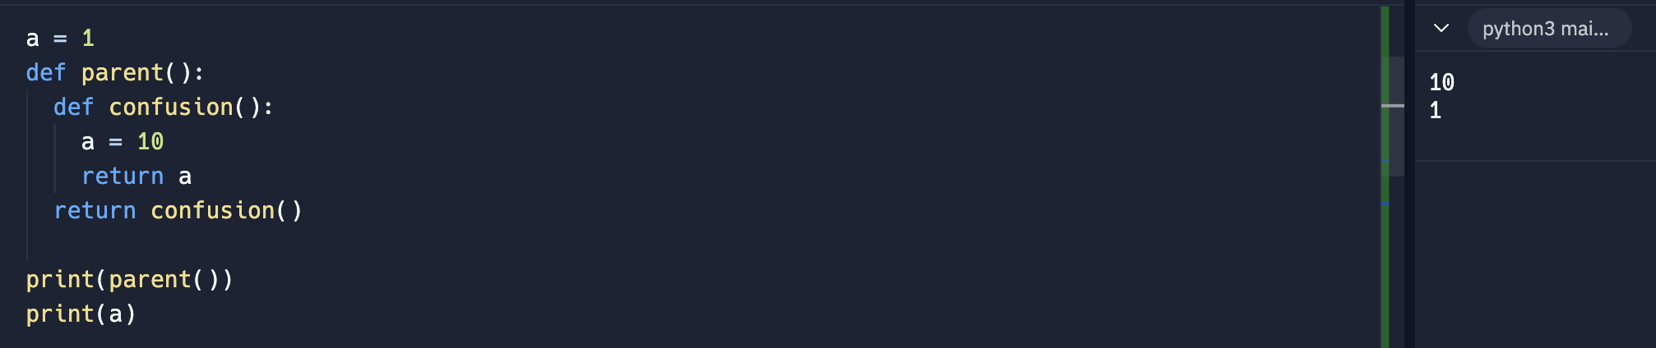
    3. Global scope
       1. 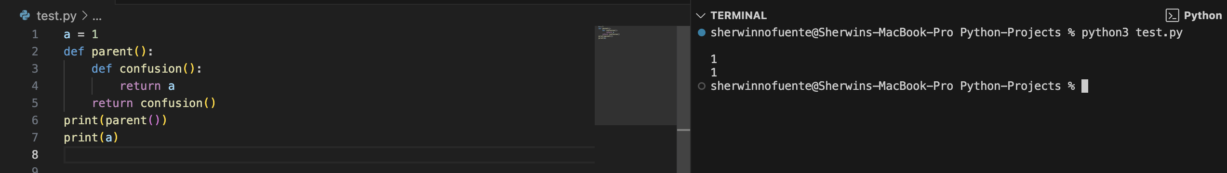
       2. When the parent() run, it executes the confusion(). The confusion returns the variable a, look locally but not available. It looks in Parent local but not available and found only the global a = 1
       3. Thus the console displays print(parent()) = 1 and print(a) = 1
    4. Built in Python function
       1. 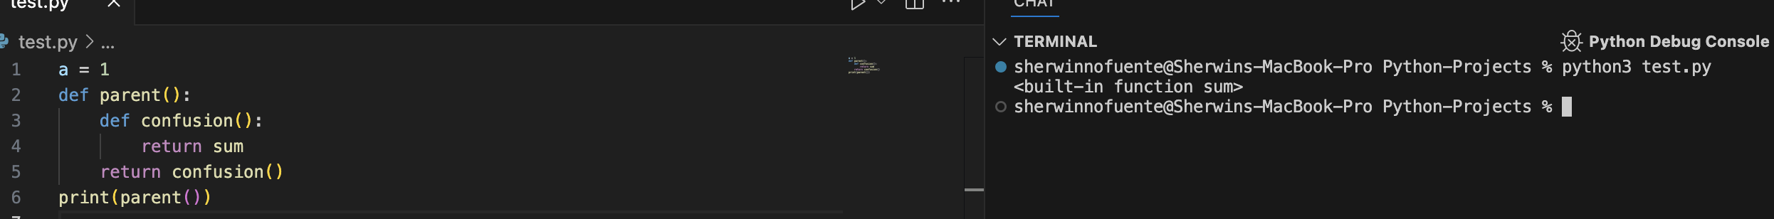
34. Global Keyword
    1. 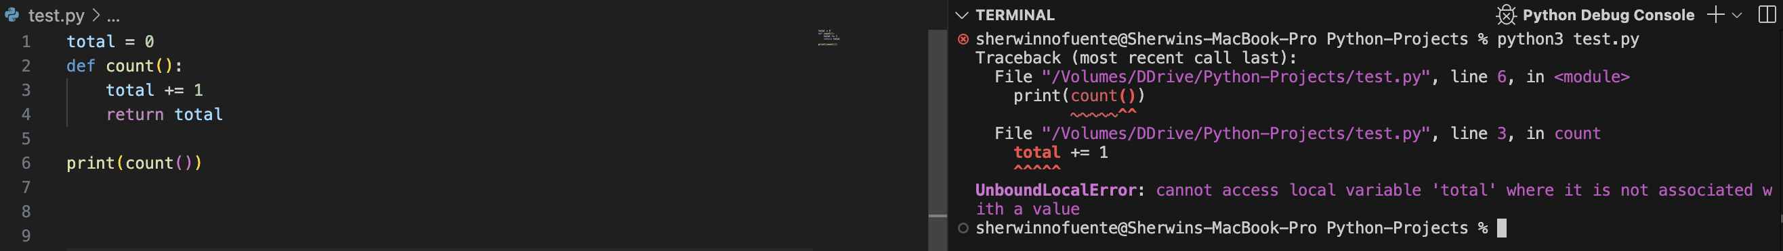
    2. This returns an error because the variable total is not declared in the count() yet.
    3. 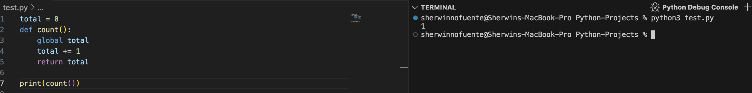
    4. Count() now runs after the declaration of the global total inside count()
    5. 
    6. The above code is equivalent to prior code.
35. Non local keyword
36. Why do we need scope
37. Exercise: Imposter Syndrome
38. Python Exam: Testing your understanding

Section 5: Developer Environment

1. MAC – Python install
   1. <https://www.python.org/>
   2. <https://osxdaily.com/2018/06/13/how-install-update-python-3x-mac/>
2. Windows Python – Install
   1. <https://www.python.org/>
   2. <https://realpython.com/installing-python/>
3. Windows get Terminal
4. Linux Python Install
5. Python Developer Tools
6. Sublime Text
7. Resources: Customizing Sublime Text 4
8. Quick Note: Upcoming Video
9. Optional: Terminal Commands
10. iTerm setup
11. Using the command Line / Terminal
12. Visual Studio Code
    1. <https://code.visualstudio.com/download>
13. PyCharm
    1. <https://www.jetbrains.com/pycharm/download/?section=mac#section=mac>
14. Code Formatting PEP8
    1. Capability of IDE to correctly format the code